Fri., August 18: The Purple Sage On Parade
I came downstairs to grab a breakfast bite at the tiny coffee shop in one of the Gunter’s front windows. It appeared closed. As I headed out with low hopes, though, I found a shop signboard on the sidewalk. I went back in and was spotted by the middle-aged desk clerk, who turned out to be the barista as well. She explained the town’s mid-session doldrums, noting it also perks up for a few weeks in fall when the “leafer-peepers” come calling. The pastry cooler was nearly empty. “I’ll take that last, lonely orange cranberry muffin,” I said. Having to turn down the coffee due to my caffeine diet, we found my only option was chamomile tea. I asked if she could do it as a “fog-latte,” and after thinking a second, she said yes. The muffin was a day old, for which she refused to charge me.
As I ate the desiccated muffin and sipped the nearly flavorless tea—not her fault, given that sole herbal option—I watched with some bemusement as she went out the front door and disappeared. A few moments later she reappeared through a door behind the counter. The next-door liquor store and mercantile are part of the Gunter complex, I thus learned.
I spent some time wandering the hotel with the camera, getting a shot off the front balcony where bands played to crowds a century ago. Others were taken off the small back balcony at the distant hills and my little purple car awaiting me in the lot to finally go home—dammit, why are my eyes watering at that?
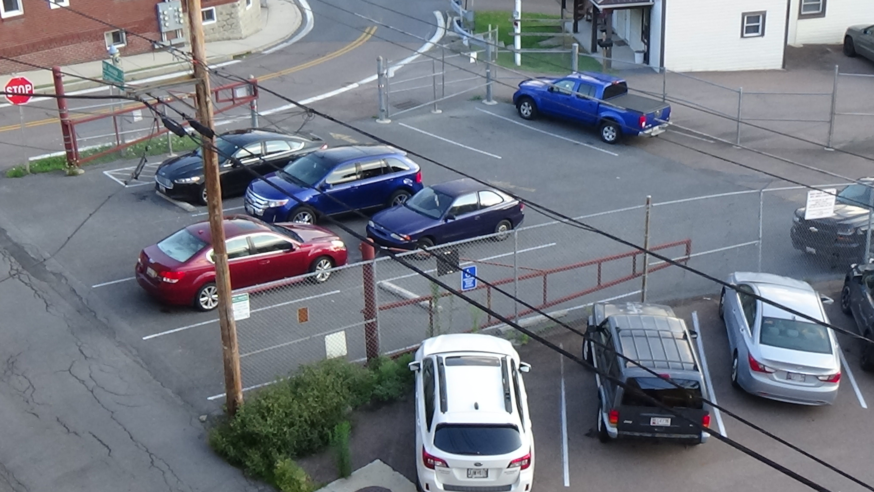
Then I headed to the basement. Besides trying to get a picture of the former speakeasy, which did not turn out well through glass, I especially wanted to shoot the jail cell.
Yes, you heard me right: The jail cell.
Frostburg’s Main Street, Alternate U.S. 40, also goes by a third, far older name, the National Road. The Lincoln Highway reflected an idea from a hundred years before, when people like Daniel Boone in Missouri inhabited the western limits of European-American settlement. In 1806, the year Lewis and Clark got back, Congress approved a road from Cumberland, Maryland, east of here, to the Ohio River in today’s West Virginia. Cumberland was chosen because a road of sorts was blazed by the British during the French and Indian War for a failed attack on modern Pittsburgh. The army trail ran through the southern edge of Frostburg, on a path too hilly for a commercial wagon road. The National Road was shifted here through the Frost’s land, hence their later inn and tavern. Eventually it was connected to a state turnpike from Baltimore that extended as far as Illinois.
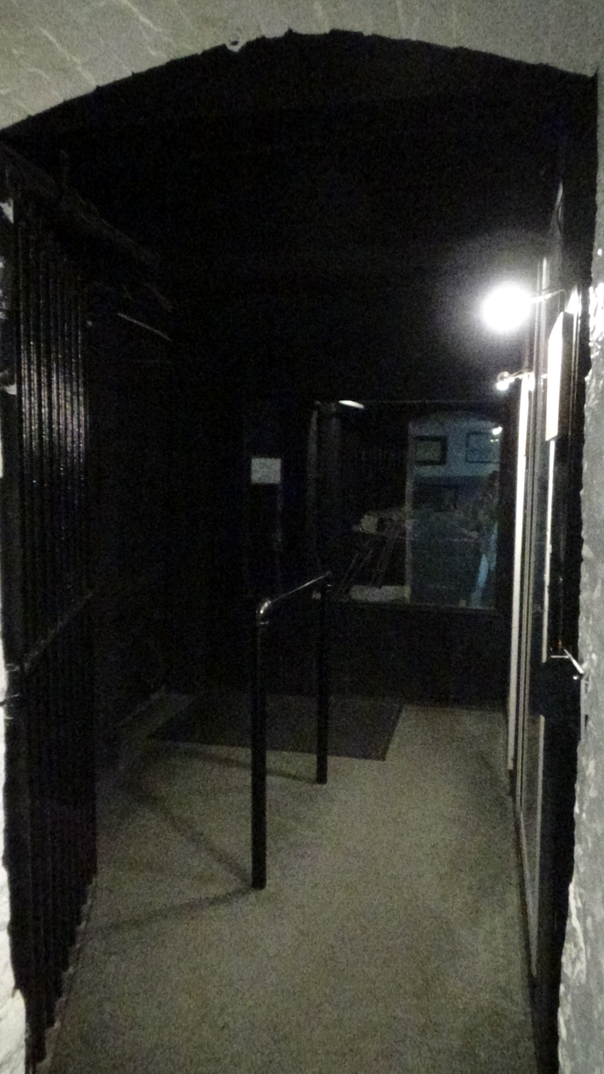
Among its travelers were law enforcement types transporting prisoners. When they stopped for the night, the prisoners were not afforded the same accommodations as their captors upstairs. The Hotel Gunter attracted the cop trade by putting jail cells in the basement. These would not have been comfortable. The one intact cell had no direct light, just what little spread through a low barred window in a common area outside the cells.
As I was dropping off my keys after loading out, I overheard a woman asking the clerk where the cells were. I said I was headed that way and could take her. In small talk on the steps down, I learned she was a history writer as well. The hallway to the steps passes through the arched doorway of another former cell, and houses exhibits from town history. She had passed through before, but it was easy to miss the dark intact cell off to the side. The standing rail in the middle may have been part of the security system; it was hard to tell the age looking at it, and hard to explain its presence except to handcuff men to, in case the heavy iron gate and very thick walls were not enough.
Back in the car, after one last load-out, there was a final campus visit to make. But I missed the tiny sign downtown pointing in the direction of Frostburg State University. Upon convincing myself I’d gone too far, I reversed course, hung a left, and found the school a few blocks downhill. The one original building from State Normal School No. 2, a teacher’s college for women opened in 1902, remains in use as “Old Main.” But the university, with 100 times its original class of 57, has flowed down and across the hillside. Below Old Main, the football team, the Bobcats, were practicing.
Ignoring I-68 as long as I could, we left town on Alt 40, a two-lane highway. Five hilly miles out of town I pulled into an old gas station with two pumps just behind another car. As its owner went to chat with a guy of my approximate age standing in the doorway of the cinder-block building with a single bay, I began battle with a possibly first-generation credit card slot. As I was about to give up, the other visitor approached and said to let him try. Figuring I could overrun him if he tried to take off with it, I agreed, and with a single swipe he got a positive response. “What did you do differently?”
“Nothing.”
“…’cause I’ve been doing the…”
“Nothing, it’s just finicky.”
He then went to gas up another car that pulled in, so I realized he was the station’s owner.
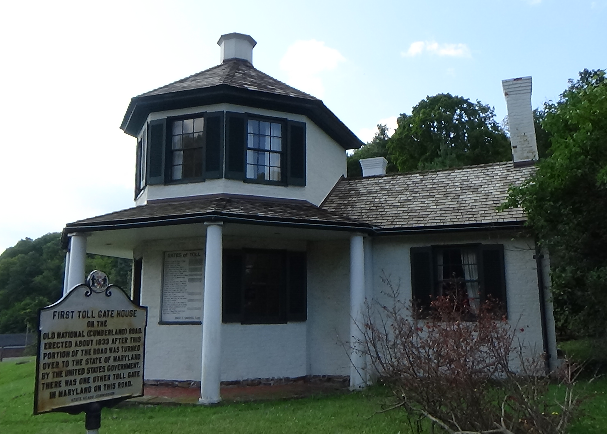
Diagonally across the road, history beckoned. Moving the car into a small parking lot on that side, I walked to the La Vale Toll House.
The National Road was “national” in name only. A marker explained. Although Congress authorized it, and there was general agreement in those days that users should pay for roads through tolls, there was no agreement on whether the U.S. Constitution allowed Congress to charge tolls. The debate raged for 25 years before an innovative solution emerged: Transfer segments to the states. This model continues today, which explains why crossing a state line on a national highway can bring a change in pavement type. The U.S. Dept. of Transportation provides money for federal highways, but the states actually do the work.
This was the first toll house Maryland built, around 1833. On the exterior wall was a listing of the tolls, based on the number of miles traveled by wagons of different sizes or horse and rider or sheep or cow. How they enforced the mileage, I don’t know. Enforcement of the tolls might explain the shape of the house. One sign suggested this made it easier to spot people trying to evade payment, though the lack of a window on the backside raises doubts. That sign also explained a term I have used for years without diving into the etymology. “Piker” means “one who does things in a small way,” Merriam-Webster says, including those who are tight with money. The sign suggested the term came from people trying to avoid paying tolls: the National Road was also known as the National Pike.
My last potential historic stop provides a minor embarrassment. A few miles farther the road emptied into Cumberland, where I found the Purple Sage’s reputation had preceded him. Scattered clumps of people were lining the route, many in camp chairs, with increasing density as we got deeper into town. I resisted the urge to wave, realizing they were out to see my car, not me.
Okay, fine… While journaling the day, I looked online and found we were preceding “America’s 9/11 Ride,” which surely explains the mass of motorcycles at the Flight 93 Memorial. I suspect I just beat the road closures.
Cops were at the ready, and one waved me through downtown, unfortunately off Alt 40. Nonetheless I found my way to my destination museum only to realize I’d been there before. “I interviewed here,” slipped my lips as realization dawned. On a trip to Pittsburgh, I sat in this parking lot and had an interview by phone for a job in Raleigh, which I got.
I was in the lot long enough this time to get passed. Picking up I-68, I soon saw a line of cop cycles on a frontage road, behind which flowed the long column of the 9/11 Ride.
MapQuest gave me three options home after hitting I-81 South: take I-68 to I-95 below D.C. and go through Eastern Virginia; cut off 68 at Charlottesville to pick up US 20, and go relatively straight down a series of two-lane roads through the height of the state; or drift southwesterly on I-81 and backtrack from Danville, northwest of Durham. MQ said the first two options timed out about the same, and normally I would incline toward the scenic route. But I had taken it in the past few years and just wanted to get home. It was mid-morning, so I figured I would escape past D.C. before the heaviest traffic landed, and took my chances.
What I didn’t account for was the greater likelihood of wrecks on the heavily traveled I-95. Exactly like the last time I chanced it, after the Pittsburgh trip, I found myself stuck dead on a “superhighway,” engine off, as emergency and tow trucks ran down the shoulder. MQ told me I was only a couple miles from the crash site, which was just beyond the next exit, so there was little point in jumping off when we finally crawled to that. I lost about an hour. “I will never again drive 95 north of me unless it is literally the only way to get where I’m going,” I told Kerrie on our first post-trip call.
The Purple Sage and I arrived home at 6 p.m., having traveled for 36 days and 9,393.5 miles.

Afterthoughts
As soon as I started East from Jack and Ann Marie’s, I felt my mood start to drag. I do not want to live in the East, and do not really fit North Carolina, for all its good points and despite having spent half my life here. I ran unnecessary errands on Saturday just to stay busy, and Sunday went to Chapel Hill for four hours. There I bought a “Carolina Volleyball” tee shirt for Lovie at a mainstay on the main drag, Franklin Street, the Shrunken Head Boutique. After sending it off the next week, I eventually got a cute selfie from her wearing it and saying she was “obsessed with this shirt.”
Trying to avoid being back home didn’t work. As I first wrote these words the Monday after, I recorded being the most depressed I’d been since semi-retiring the December before.
But for more than a month on the road my chronic low-level depression had disappeared. I write these words six months after the last paragraph, delayed by my having unretired halfway through. When the job provided unexpected stresses, the depression soared. Now out of that and thus those, I’m back to most people’s normal—not depressed—meaning above average for me. A theme of the trip emerges.
Summarizing the research literature, two scientists pointed out people tend to try to gain more power, but the primary drive is not for “social power,” control over others. Social power is a tool toward the ultimate goal, which is “personal power,” meaning “the capacity to control one’s own outcomes and not to be controlled by others. In other words, if individuals want power, it is mostly in order to be able to act in agreement with their preferences and desires without adjusting their behaviors to others and/or to social norms.” This is ultimately what drove Daniel Boone over the Cumberland Gap, and formerly enslaved pioneers to Nicodemus, and the emigrants of the California and Oregon trails, and even In-mut-too-yah-lat-lat (“Chief Joseph”) of the Nez Perce.
Since adolescence I have highly valued what I called “personal freedom”; other values have changed completely or in priority, but that remains near the top. I suspect the ultimate reason for my romance-less state is that one must give up a portion of personal freedom to enjoy a successful intimate relationship. I would have to have gotten more than one can reasonably expect from a romantic partner to give that up for a lifetime.
Add in my wide-ranging curiosity, and a 1984 career test that said what I love most work-wise is researching and writing, confirmed over and over throughout my career. Thus when I am traveling, alone, with full control over my itinerary, learning as I go, and writing about it—this the perfect combination for life. This is my happy place, or more correctly, my series of happy places.
This bias of mine toward personal freedom explains most of the opinions I have expressed here. I agree with the writers of the U.S. Declaration of Independence that all people have a right to pursue happiness. However, I think this right stops at the edge of taking away the happiness of others in order to gain your own. Again and again on this trip, and in the headlines every day, we see examples of people using social power to restrict the personal freedoms of people not like themselves—making themselves happy at the expense of other’s right to pursue happiness. I will always stand with the latter.
You will filter those opinions through your own values, and thus may take away very different lessons from mine. That’s fine. But I hope the true stories you read here have not only entertained, but perhaps given you reason to question what you have been told to believe by others. I freely admit my bias toward personal freedom, while asserting that my facts are as objectively accurate as a human can make them. I hope you will embrace the personal freedom to consider what the evidence tells you, instead of listening only to sources saying what you want to hear.

Schools for teachers were called “normal” schools, and some outside the U.S. still are, because they were intended to help impose societal norms on students.
https://www.merriam-webster.com/dictionary/piker.
Brauer, Markus, and Richard Y. Bourhis. “Social Power.” European Journal of Social Psychology 36, no. 4 (July 2006): 601–16. https://doi.org/10.1002/ejsp.355.

