Sat., July 29: A Gap, a Boat, and a Miracle
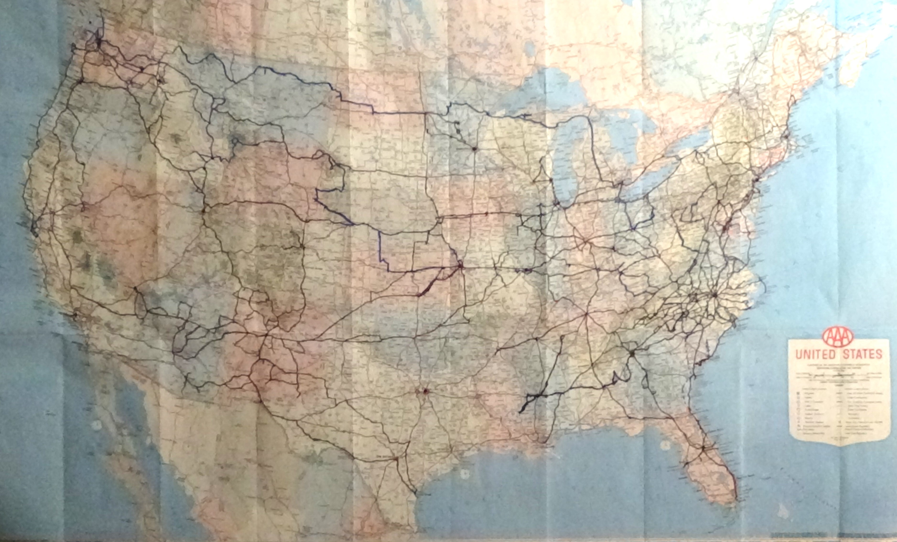
On a wall in the bedroom I still call the “Ferret Den” is a 1997 AAA road map of the United States. On it I’ve marked in Sharpie everyplace I’ve been on the ground: blue lines where I drove, green by bus, hash-mark green by rail, and green dots for each airport. It is a spiderweb of lines, as you can see. A few gaps irritate me, particularly the big one on I-40 through Texas.
Before Kerrie moved back to Poky, I figured I’d fill it by driving out to visit her. Like ripples on a pond, Sharon’s dementia sends out waves of impact, faint at my distance, yet there.
There used to be a tiny gap on I-90 between Spokane and Central Washington. Eleven years living in the state, and I never saw that stretch of its only East-West interstate. Today I fixed that, with a two-hour drive. The view was of high plains, much of them covered in crops. I was intrigued by a sign I’d never come across in all those blue lines of driving, announcing there would be “Crop Signs” for the next 14 miles. This is a great idea. Despite being a city boy with low interest in plants, I’ve managed to figure what a lot of crops look like. But driving around the back roads of North Carolina I still sometimes see something I don’t know. Given the huge disconnect between most Americans and the sources of their food, what a simple tool this is to slightly bridge the gap. Hanging on the fence along the next field was what looked like a home-made sign naming the crop. I recognized a lot of them along the way, but potatoes (the above-ground part) and alfalfa were new learnings.
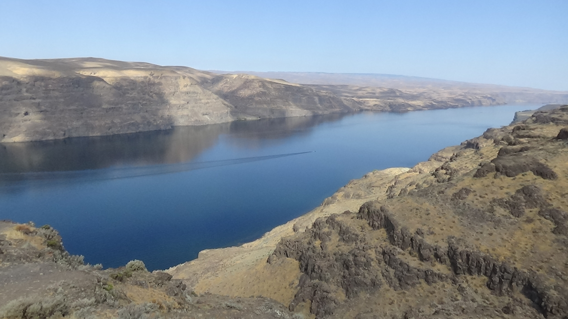
Just before Vantage in the middle of the state, I pulled off for a view I’d seen before, but can never be seen enough: the Columbia River’s gorge, here a placid blue line between cliffs. Not as deep as the more celebrated part along the Washington/Oregon border, it is breathtaking nonetheless. The Gorge Amphitheater is just upstream from this point, to the right in the photo. Placed in a natural bowl opening onto the river behind the stage, it is one of the more extraordinary places to see a concert in America. While living in Seattle, I caught a festival with a music-loving friend who flew across the country just to go.
The rest of the drive I’d made many times, crossing the Cascades over Snoqualmie Pass and hugging Keechelus Lake. Approaching Greater Seattle, the MapQuest-derived itinerary had me taking the I-405 bypass to Edmonds north of the city. But traffic from it was backed all the way onto 90, so I took a chance on going through town instead. This led me onto the floating bridge across Lake Washington, the most beautiful urban lake in America. A glacier-carved finger lake like those in New York State, it runs 22 miles along the east side of Seattle-proper with suburbs beyond. Microsoft founder Bill Gates has a nauseatingly large house on it, which I passed by daily on another floating bridge to the north when I worked at Microsoft.
In town I ran into more traffic on I-5—Seattle is consistently on Top Five Worst Traffic lists in America—but here I knew how to get around it. I dumped off on Madison Street and wound along familiar streets through the heart of town, re-entering into a slow-but-flowing line. In 15 minutes I exited again to continue west, ending up at the entrance ramp for the Edmonds-Kingston Ferry.
Washington State has the largest ferry system in the United States (North Carolina’s is second). Seattle sits on a wide sound separating it from the Olympic Peninsula, whose far-side neighbor is the Pacific Ocean. An arrowhead sticks up in between, the Kitsap Peninsula, appearing as an island attached by a sliver of land at its base. Several islands lay between Kitsap and Seattle or towns south, but only one bridge far to the south. Ferries are the bridges.
Warned I might have to wait an hour, upon pulling into the loading lanes I was happy to see it would be half that. I turned off the engine along with everyone else, rolled down my window, and picked up my book about English kings discussed in the hotel laundry a week or so ago. (I didn’t have a lot of reading time, and purposely borrowed a thick book.) The day was warm but not hot, as usual on the Puget Sound, though less usual as climate change settles in. There was a bathroom one lane over, which I hit as takeoff time approached.
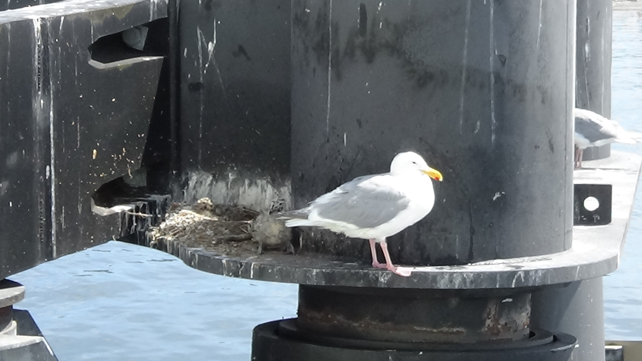
The ferries take four lines of vehicles on two levels; the Sage and I were directed to the second level, port side. When I got out, a woman was pointing out a seagull nest with a young’un to her young’un. Having made the run before, I decided against going up to the passenger desk, and just enjoyed watching the Sage make his fifth lifetime crossing on this ferry. It was both satisfying and numbing to realize we had reached our geographic endpoint, 3,200 miles from where we’d started (had we driven directly). I leaned up against him and watched the water rush by, then stepped back to get a video and the shot of him below.
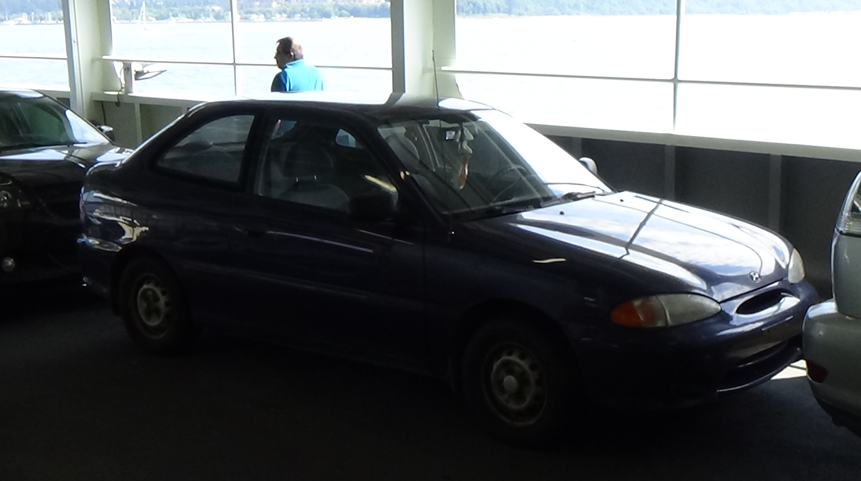
Jack and Anne Marie Snowden live a few miles from the Kingston Terminal. I met Jack soon after arriving in Pullman, when I went in search of the best martial arts instructor in town. This is why my highest rank is only a 2nd-degree black belt (out of 10). Had I stayed in formal training in a single style, I’d be an 8th or 9th after 40 years. But my practice has always been to seek out the best instructor in each town I moved to, regardless of style. And if there is no good instructor, I’m better off training on my own than developing bad habits. As a result, I also have a black belt in taekwondo, a brown belt in shotokan karate, and lower ranks in various styles. I last trained in muy thai, which doesn’t have ranks.
Having spotted a flier on campus for a karate club, no doubt I had to ask for directions to find my way to Room 21 in the basement of Smith Gym. The gym is built into the side of a hill, so I entered the building from a door on the back side four stories down, and took a last half-flight to the open Room 21 door. Beyond it was what looked like an undersized basketball court. The class was under way, but Jack felt my presence. He turned to look at me, I looked at him, and it was the closest I have ever come to love at first sight. As he confirmed later, we both knew we were going to be friends for life in that instant.
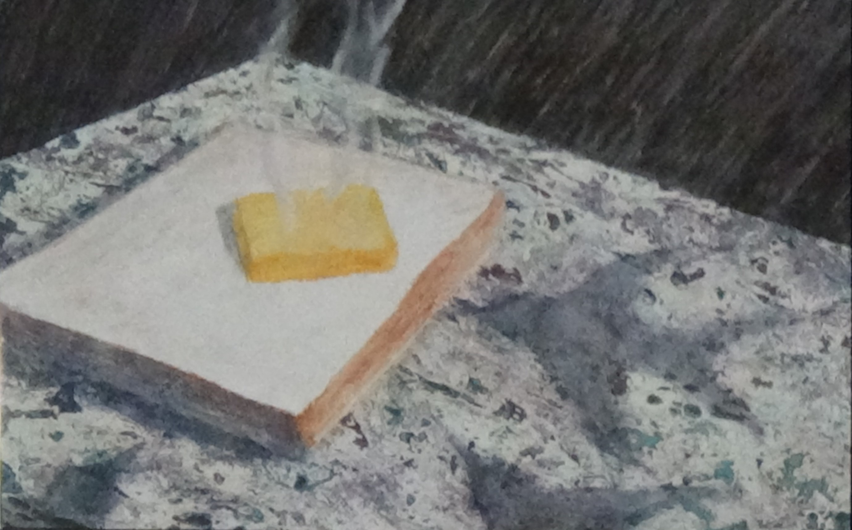
I trained with him starting with the next class, and he was excellent, in both fighting and teaching skills. He almost immediately made me a co-teacher, and within the year turned the club over to me, feeling he didn’t have time for that along with his teaching duties in the interior design school, family responsibilities, and painting. Jack is a gifted visual artist, creating twists on reality that often seem fairly normal until you pay more attention and find something that isn’t quite right—like one on my wall of a piece of toast with a steaming pat of butter that isn’t melting, or landscapes with zippers on the horizon. After leaving WSU, he worked for years doing background work for Nintendo games in the town where Microsoft is based, Redmond. He let me room with him when I moved to Seattle from ABQ in 2000. Later he served as the dean of game design at the Seattle Art Institute. Now he is involuntarily retired due to age discrimination, the only possible explanation for his inability to find a job in the video game industry.
Ann Marie is an equally gifted Pilates instructor, formerly working out of a yurt we assembled for her in their Redmond backyard. After a move to Texas they came to Kingston, and she worked as a grocery manager for a while, though she is retired now. Jack leans Buddhist, though more into what he calls “the oogah-boogah,” and both are very liberal, so the contrast between these hosts and my previous set could not have been more stark.
I pulled into their driveway before a cute house with a lively yard, bushes and flowers mingling in front with the grass, and a fenced garden in the back. Jack was sitting on the front steps cleaning hiking shoes. He looked up at me as if we had drinks the night before, offered no greeting as such, and we dropped right into normal conversation just like our occasional phone calls. Their home is cool inside, in both the cultural and climate sense, covered with paintings and New Age décor, Ann Marie’s Pilates equipment filling the living room. He had built a hydroponics frame in the garage, so he can grow veggies in the winter. Baby broccoli, I think, was peeking out of one of the holes. I greeted Ann Marie with a hug, and we all settled onto the back porch lounge chairs for a chat.
After we’d caught up, Jack suggested a walk around the neighborhood. This circled within view of the ferry terminal downhill. Then he suggested a hike. He pulled some walking sticks from the back of his Jeep, which I tried to decline. He insisted, and they did come in handy in the way a machete does, though the latter would have been more useful. We dove into the woods directly behind the house along what he called a “trail” but I would dub “perhaps a trail when Native Americans owned this place.” Thank goodness I chose to wear my hiking shirt, because I used the stick mostly like a shield in a Bronze Age battle against the thick greenery. “Watch for stinging nettle,” he said, pointing some out, which I’d only seen in photographs.
I affirmed I was, but then said, “Ah, it got me a little.” My right wrist began to burn as if I’d bumped against a soldering iron, as I have done. At the source a welt was rising. Soon after, we swung onto a double-track, and he began looking down. “Rub some of that on it,” he said, pointing to a fan of leaves growing close to the ground. I picked a few, crushed them, and began rubbing. Within 30 seconds, the pain was gone. I mean, completely gone, as in it never came back, even thought the welts took a week or more to disappear. Jack has been studying herbs and medicinal plants for many years, so I was both astonished and not surprised in the least by this miracle.
At the end of that road we came to a fence, beyond which a large section of the forest had been clear-cut and terraced for a residential neighborhood. The next day he drove us to the far side, where a sign said the developer was Pulte Homes. I told him I was definitely not surprised. Pulte’s environmental arrogance is evil. It routinely clear-cuts and plants puny starter trees rather than taking the time to work around mature ones.
The walk in both directions was slowed by constant stops to eat fresh blackberries straight off the vine, one of the activities I most miss about living in Western Washington. He introduced me to another variety I’d never heard of, salmonberries. The name refers to the color, not the taste, thankfully. Each is a little cap of fruit, tart and tempting, that slides off the head at the end of its branch.
Back home, Ann Marie served us homemade hummus, pita, veggies and fruit cups on the back deck. I was quite sure I was never leaving.

American Automobile Association.
That didn’t mean we would. This is just another form of coincidence, a mathematical inevitability on one end of the bell curve. What “love at first sight” couples fail to account for is the far greater number of couples who have that sensation and it doesn’t work out, and those who make it without the “first sight” experience. I still enjoy the memory as if it had some cosmic significance.
He called it “plantain,” (not the banana-like thing).

