Fri., July 28: Melancholic Nostalgia
Guy is a lifelong biker, and the new pride-and-joy of his life was a brand new blue Harley- Davidson. After some adjustments, we managed to get a helmet over my head, and I hopped on back for a return to the diner from yesterday’s lunch. Holding onto my seat back, I enjoyed freely looking around, seeing the Spokane River and downtown unfiltered by a car roof or windows. At a stoplight he checked on me. “I’m smiling like a hyena,” I said, and had been pretty much the whole ride.
We were headed to what I dubbed Guy’s “Friday Coffee Klatch” with, I predicted correctly, folks of his political bent. Each is a character in his own right—there is a female, but she was absent—but I was especially drawn for obvious reasons to a photographer for the local daily newspaper, The Spokesman-Review. In introducing us Guy bragged on me as a Mizzou master’s graduate, which the gentleman acknowledged with respect. We had an additional connection through history, for he told me he had started a “then and now” column showing old pictures of buildings compared to what is there today. I asserted he was helping the paper’s circulation, citing a major spike in AmRevNC’s viewer numbers after one of its pages was cited in a similar feature on the WRAL.com website. He agreed, saying data suggests he helps retain subscribers, but only older people take the physical paper anymore.
To the group I made the argument, as I often do, that the easiest way to get relatively unbiased news is to go to the Associated Press website. For the benefit of the two other gentlemen at the table, I explained AP is a cooperative. This means every news outlet that subscribes to it, the vast majority in this country, is a part-owner. Fox News owns it; so does MSNBC. The New York Times and Wall Street Journal are both owners, papers considered liberal and conservative respectively, though I don’t see either as biased in their news coverage. I speak with some authority, having written a large research paper at Mizzou on whether objectivity is possible in the news, and whether there is value in trying. (Conclusions: Traditional journalists follow processes designed to limit the impact of conscious and subconscious bias; and, yes).
The photog claimed AP is getting political, too; I didn’t want to get into an argument, so I let that lay. More disturbing was his news that the S-R had dropped its membership/subscription because it could no longer afford it.
The group approved of my standard response to comments I questioned: “What’s your evidence?” If I am extreme about anything, it is empiricism. I believe the vast majority of the world’s problems are caused by people refusing to accept objectively verifiable evidence just because they don’t want to believe it. Anyone can change my mind if they present better evidence than I have. That means, for example, meta-analyses (studies that combine data from multiple studies on a topic) instead of a single study, or the commonalities in multiple eyewitness accounts over the claims of a single individual. On that basis, I have repudiated a number of my prior beliefs, very publicly in some cases. On the other hand, positions I am an expert researcher, so the number of times that has happened is relatively small simply because few people are geeky enough to out-research me in my areas of interest. Where I haven’t done the research, I accept the consensus (if any) of those who have, generally scientists.
One wag said he was going to make a minor modification: “What’s your evidence… for your stupid opinion?” We all guffawed.
I don’t know how we got on the topic, but someone said Civil War reenactors preferred to wear the blue uniforms of U.S. soldiers instead of the gray of the Confederates, but someone had to be on the other side. They seemed surprised as I explained that in the South, the people in gray wanted to be. At one gentleman’s prompt, I confirmed those people often denied slavery was the war’s cause. Had this meeting happened in the South with conservatives raised there, they would, too, I didn’t add.
It was fun, but I’m glad I’m not close enough to be a regular at Guy’s behest. My tongue was half its original length by the end of the gathering. I am extremely glad Guy has a regular social outlet he enjoys, however, and am grateful to the group for that. I had to physically tug him away outside, because I had a plan for the day. I was going back to Pullman.
We had a small adventure before I could do so. On the way home, my seat back fell off. Fortunately I was holding the metal bars formerly holding it. I tapped Guy on the shoulder, gave him the “turn around” signal, and told him the problem when he pulled over. We found it.

Starting toward Pullman from the Pace home was pleasantly easy, as US 195 is a short drive downhill from them. Slowly the trees and plateaus south of Spokane gave way to one of the most unique topographic regions in the world, called “the Palouse,” probably derived from a mispronunciation of a Native American nation’s name. I have long described the area as “sharply rolling, treeless hills.” Most are farmed, despite the elevation and slope. The tractors and harvesters have to be “articulated” such that the cabs can stay relatively vertical while the working parts parallel the highly angled ground. The hills, stunning in themselves, change colors through the year from brown (fallow) to green to straw to white (snowy). They are also highly productive, having among the highest yields of wheat per acre anywhere in the world. That’s because the topsoil in unbelievably deep, hundreds of feet at some points.
At its edge, I pulled into a rest area that was a national historic site. I have no idea why. It was built in 1966, and is not especially appealing. The shot below looks east across US 195 from there.
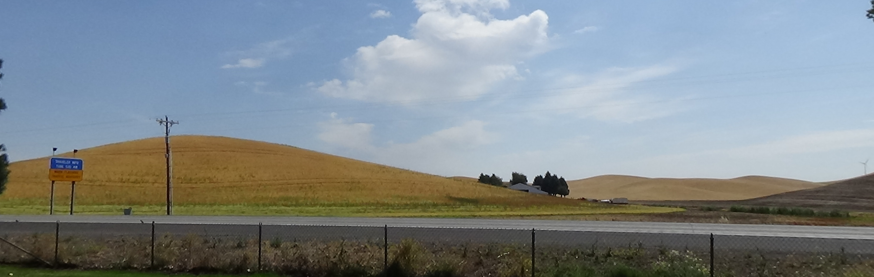
The two-lane highway took me past my beloved Steptoe Butte, a far larger hill I had hiked a number of times, including knee-deep in snow. It then dropped me into Pullman after an hour’s drive. The town’s history is pretty much that of every non-Native town in the West, but it presents two singularities. History nerds might reasonably assume the town’s name has something to do with the well-known Pullman railroad cars, but not so much. Contrary to local origin myths trying to connect the name to that company’s 19th-Century founder, George Pullman, it appears the first postmaster in the 1880s chose it for unknown reasons. The other difference from most towns is the state’s land-grand university, explained back in Missouri. What now is called Washington State University was founded on a hill above town in 1890. The town boasts a population around 30,000, but students may be the majority most of the year. Certainly it is the classic isolated college town that effectively goes to sleep between school semesters, as it was now.
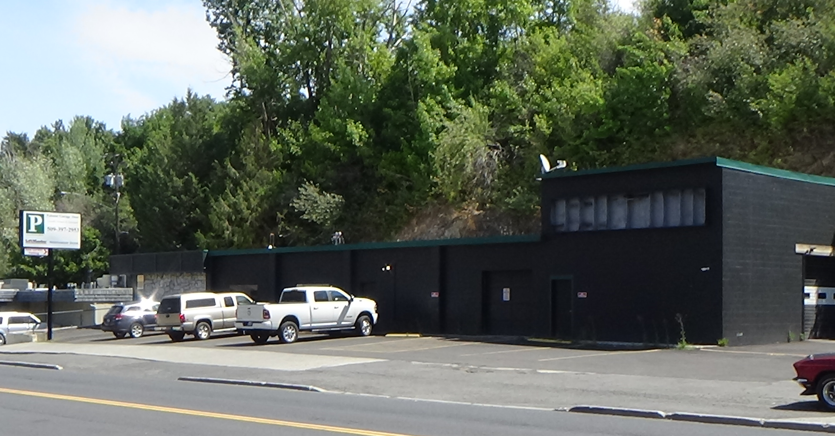
The town proper centers on the T-intersection of state highways 27 and 270, which leads eight miles east to Idaho. I slid past 270, Main Street, to what once was the Pullman Herald, long closed. Now it’s a garage door company. The taller section on the right of the building once held the presses. We inserters did our thing in the hall behind the loading door to its left.
Don’t worry, I’m not going to take you to every spot in town of personal significance. My history is not History.
I tried to grab lunch across the street at the Old European Restaurant, after verifying on a menu there was something I could eat. No one was at the front counter. A waitress was yakking to a friend with her back to me in the far corner, and kept right on doing so. I know the friend saw me, but the server never turned around. After standing there at least three minutes, I left and drove to a free parking lot in the compact downtown. When my mother visited, her first traverse west other than a trip to San Francisco, she was delighted by what she considered its Old West feel. A couple of places there were not open betwixt semesters, so I tried the Thomas Hammer Coffee Shop, a regional chain. They had sandwiches. I went for a caprese washed down with a pomegranate Italian soda.
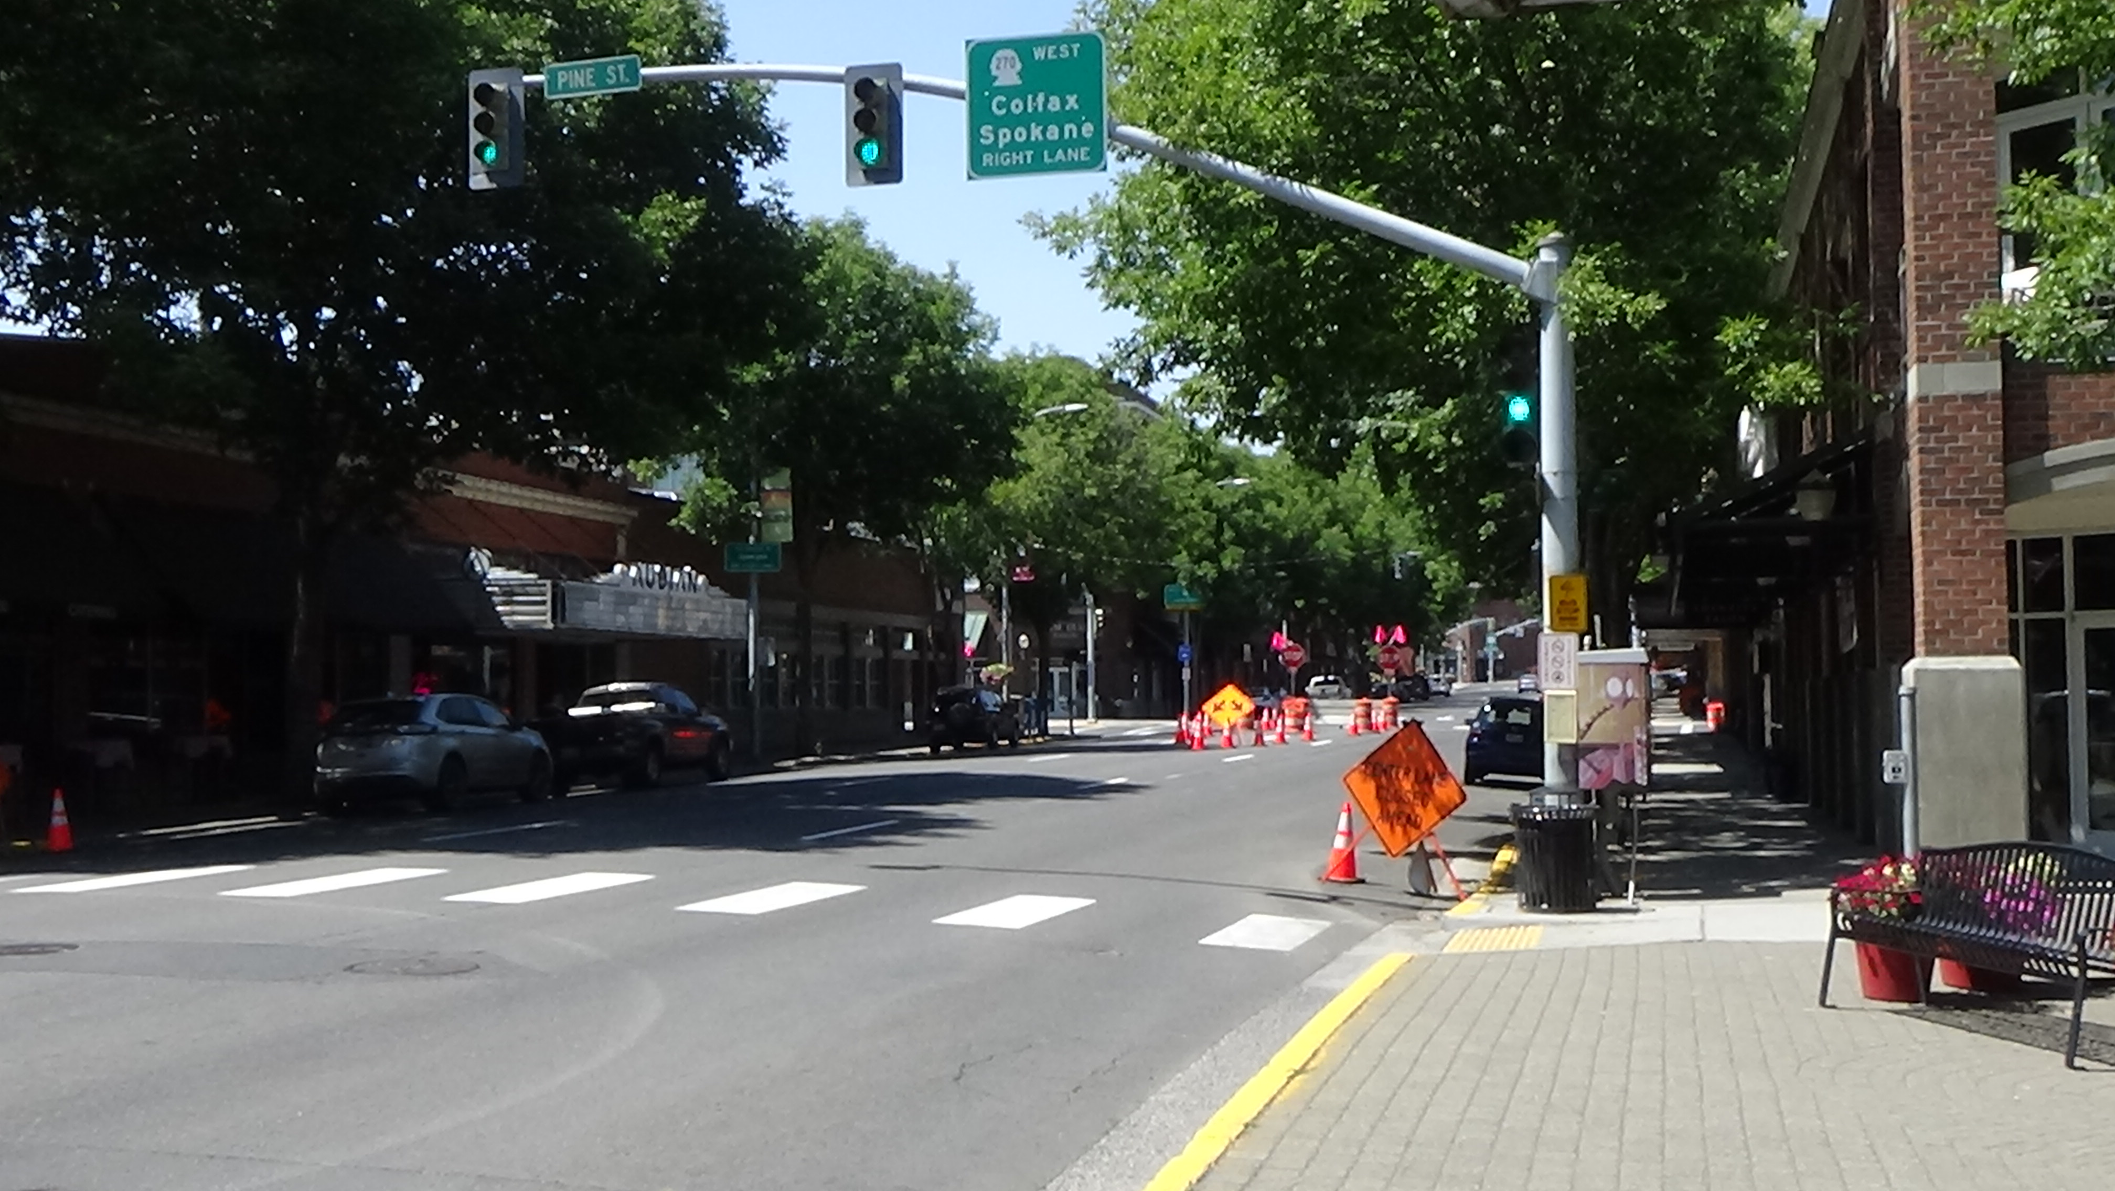Main Street in Pullman, looking west
As I waited, I overheard the young woman who took my order, whose shift was about to end but was sweeping, say she didn’t want to leave a mess for her co-workers to clean up. I complimented her on her diligence. We ended up in a conversation about ethics. She said, “human dignity is important to me,” in this context meaning her co-workers should not have to do something she wasn’t willing to.
I drove to another former workplace, which I’ll discuss simply for a funny moment. My second job in the area, not counting the Herald, was at the local Quality Inn. (I mentioned this gig in Pocatello.) I started as a night auditor working the overnight shift, and got promoted to assistant manager, basically in charge of daily operations, bookkeeping, etc. Today I stepped in to see the lobby, assuring the college-age clerk on duty I didn’t need anything. I had worked there long ago, I said, and was just checking it out. I was there when the building was extended with some mini-suites, I told him. He said I had “worked there a really long time ago.” He instantly realized what he had done and started to apologize, but I waved him off with a laugh, saying he was right.
Nearby I stopped in the Crimson & Gray store, the WSU equivalent of Tiger Spirit in Columbia. All I bought was stickers for my car and computer. “I’m pretty well (geared up),” I told the clerk, “but I couldn’t just drive through Pullman without picking something up.” He said he heard that a lot. I didn’t tell him the other reason I stopped in. The last time I visited there, Steve was with me. The mug I bought that day is one of my most prized. It’s sitting next to me as I edit this.
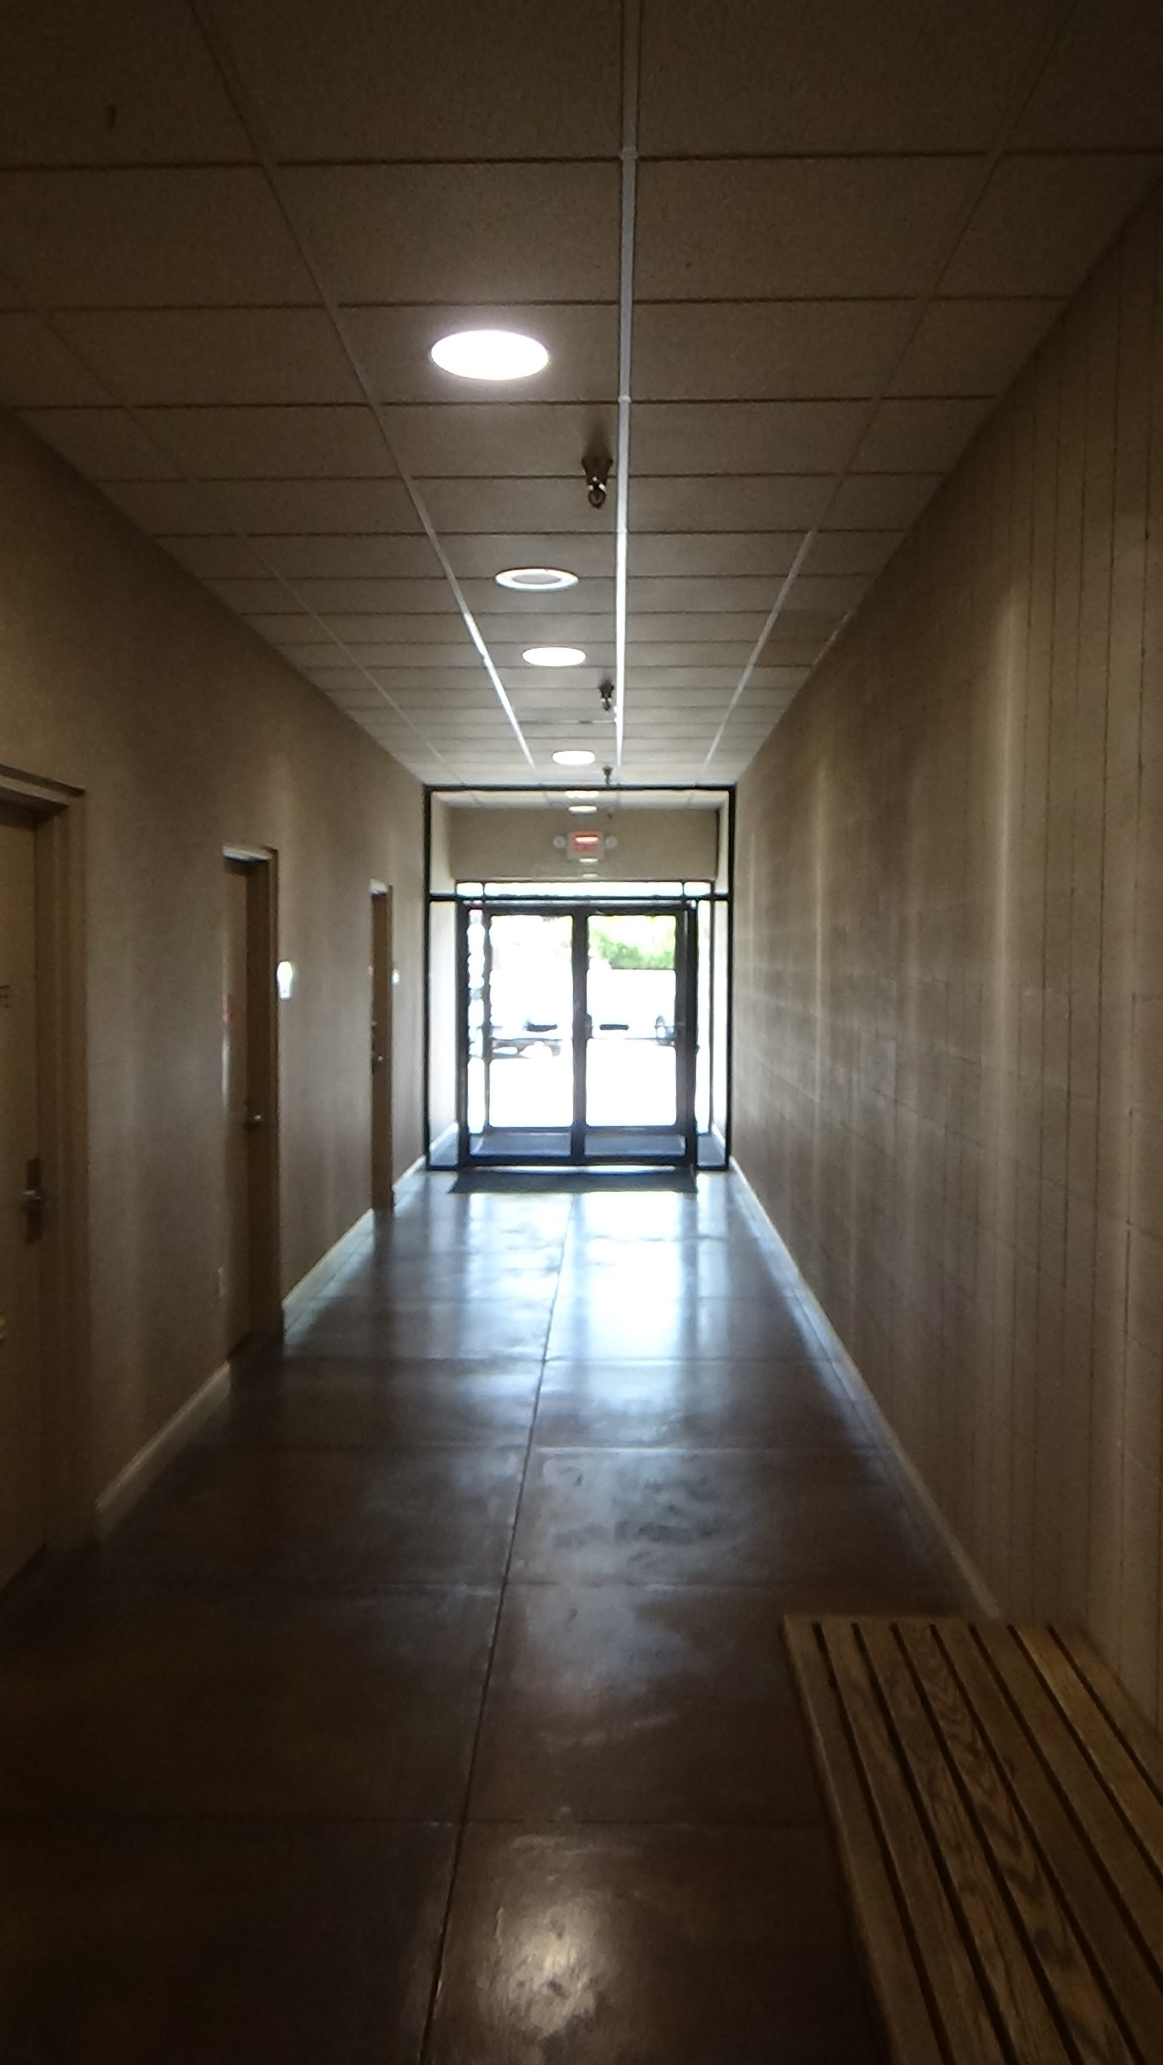
I drove the eight miles to Moscow, which in the news the prior year because of the horrific murder of four University of Idaho students in their beds by a WSU grad student. I thought of them as I passed the university, wended east, south and east through downtown, and to a shopping center. I wended my way east, south and east through its quiet central core, noting that a former anchor store is now a church, ending up in a nondescript hallway by the back door to a business I’d passed. This was the former office of The Whitman-Latah Republic, the weekly newspaper of which I was the editor, my first local job. I’d gotten it through the publisher of the Herald. Unfortunately, the paper was in its death throes when I arrived. The fact the publisher, whose primary job at a small-town paper is to sell advertising, rarely left his office, was a major factor. It didn’t help that he was clinically paranoid. For example, he regularly made mistakes mailing out the papers. When the Post Office rejected his paperwork, he blamed the local daily newspaper, saying the publisher was in cahoots with the PO. I loved the work, but couldn’t handle the stresses he laid on me. I only lasted six months. A month after I quit, the paper folded.
By this point in the trip, the Purple Sage looked more like one of my earlier cars, the Brown Beast—except for the front, which was nearly white with bug DNA. Recalling where a car wash was nearly 40 years ago, I gave it a shot, and sure enough… However, running him through it served merely to remind me that touchless is worthless for heavy grime.
On the quiet WSU campus, I noticed the gates were up at the central parking deck, which made sense given the same was true at Kentucky. Maybe two cars were inside, until the Sage became the third. My third and last job in Pullman was at WSU, as a writer for the colleges of business and agriculture, and a martial arts instructor in the physical education program. These totaled only 3/4-time, which I wanted, because I began a lifetime of reading and writing about scientific studies by researching a book on the science behind romantic attraction.
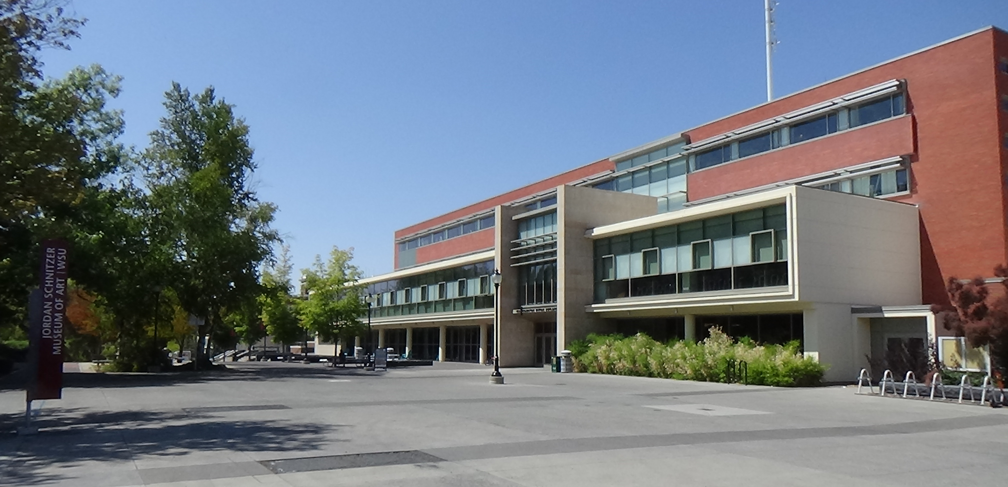Compton Union Building on WSU's central concourse
I drifted around all the places where I had spent significant time, feeling nostalgia tinged with melancholy. Instead of the good times when I lived there, my thoughts kept settling on the fact the last time I’d done this tour, Steve was with me.
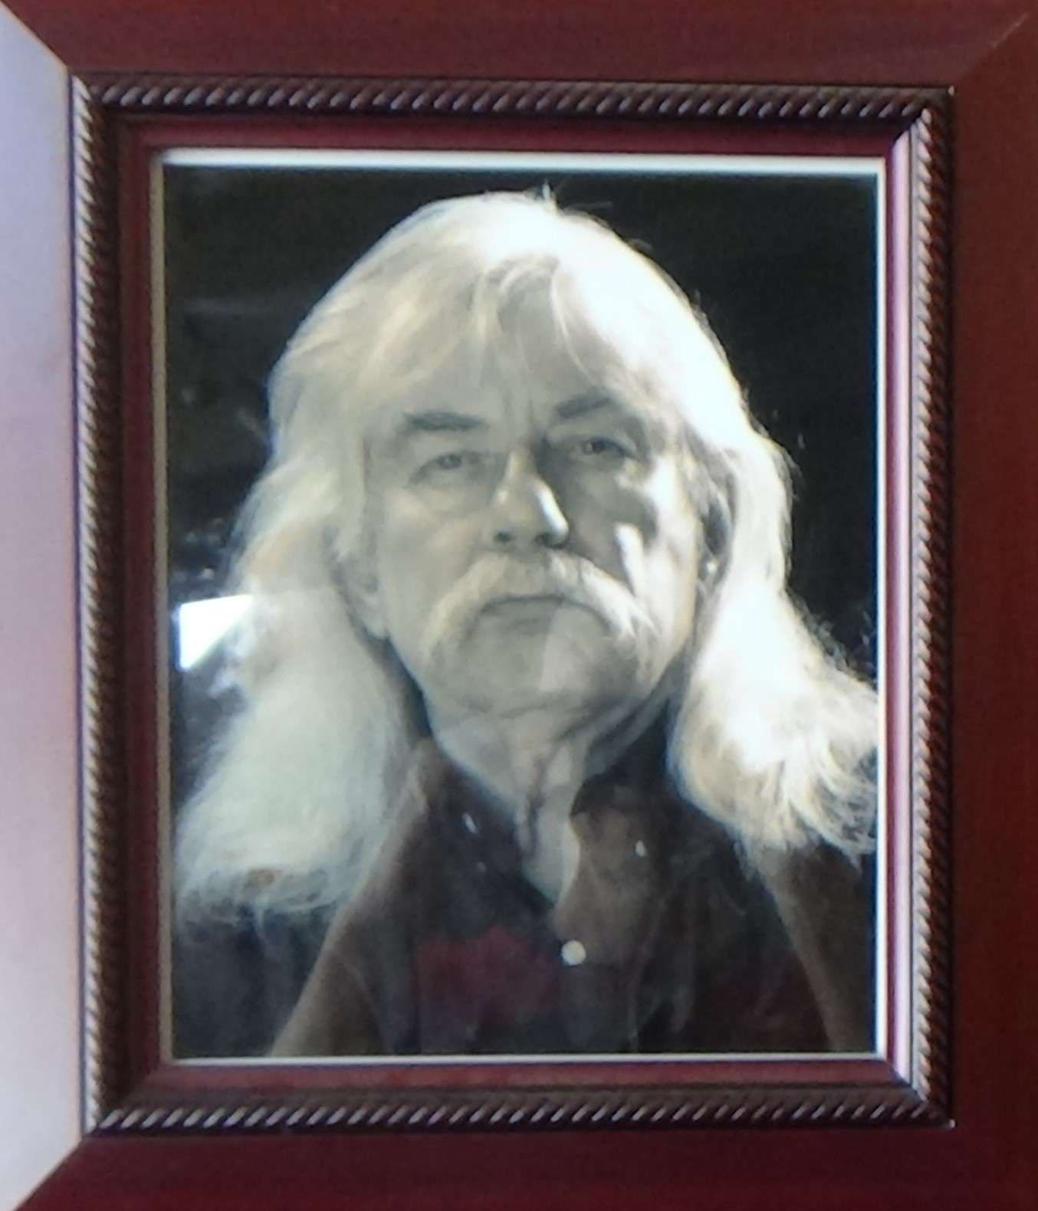
One pleasant moment intruded when I visited the theatre. This was the last place I did lighting design, for Jesus Christ Superstar in their summer repertory. I got rave reviews, in the form of a complimentary sentence in the one printed review of the show. The lobby door was open, but not the theatre, and I saw no indication the rep continues. I knew I would not see Paul Wadleigh, the drama professor who served as producer of the rep and directed Superstar. He was a leonine, silver-maned and -tongued personality of retirement age then. Happily, I was wrong. On leaving, I spotted the name on the smaller “black box” theatre: P.C. Wadleigh. His dramatic persona oozed from a picture by the door, looking far more fierce than the teddy bear inside the man.
I finished up at the library where I spent so many engrossing hours; the gym where I taught martial arts (not noticeably changed, though Room 21 is now a laboratory); and the football stadium, before going back to the car. There I found a parking ticket. Turns out the gate wasn’t down, it was gone. I had stopped at the ticket dispenser just in case, and none came out. I presume they now require use of an app, which I refuse to use as discussed in Columbia. WSU hit me with a $60 penalty for parking in a virtually empty deck with no one around. I have not paid. It’s not a moving violation, so the worst they could do is put a boot on my car if found in Washington. So I can never again drive my 24-year-old, 200,000-mile-plus car 3,000 miles back to Pullman. Bummer. Not for that reason, I somehow knew I was never again going to visit this place that was so formative to who I am today, even without my attending the school.
There was one last stop to make, though. I circled around on Stadium Way, which loops halfway around campus, stopping for shots of the two apartments Steve and I shared before he moved in with his later wife. Then I went back downtown to the same parking spot from my lunch run. I crossed Main Street and walked one last time into Rico’s.
This tri-level bar has existed since 1911, though it moved to the current location sometime in the 1930s, the bartender thought. If she didn’t know, no one did: She was the owner, and the daughter of the man who owned it when I lived in town, spending a prodigious amount of time here. The billiard tables were still upstairs, as was the bathroom with the metal trough in the place of urinals. In the split-level bottom floor remained a music space with no visible changes. A bookshelf wall still fronted the upper staircase, and stained glass spread light over the table past the bar. There late one night, Steve, his then-girlfriend and I decided to spend the next day in Seattle on a whim, despite it being four hours away.
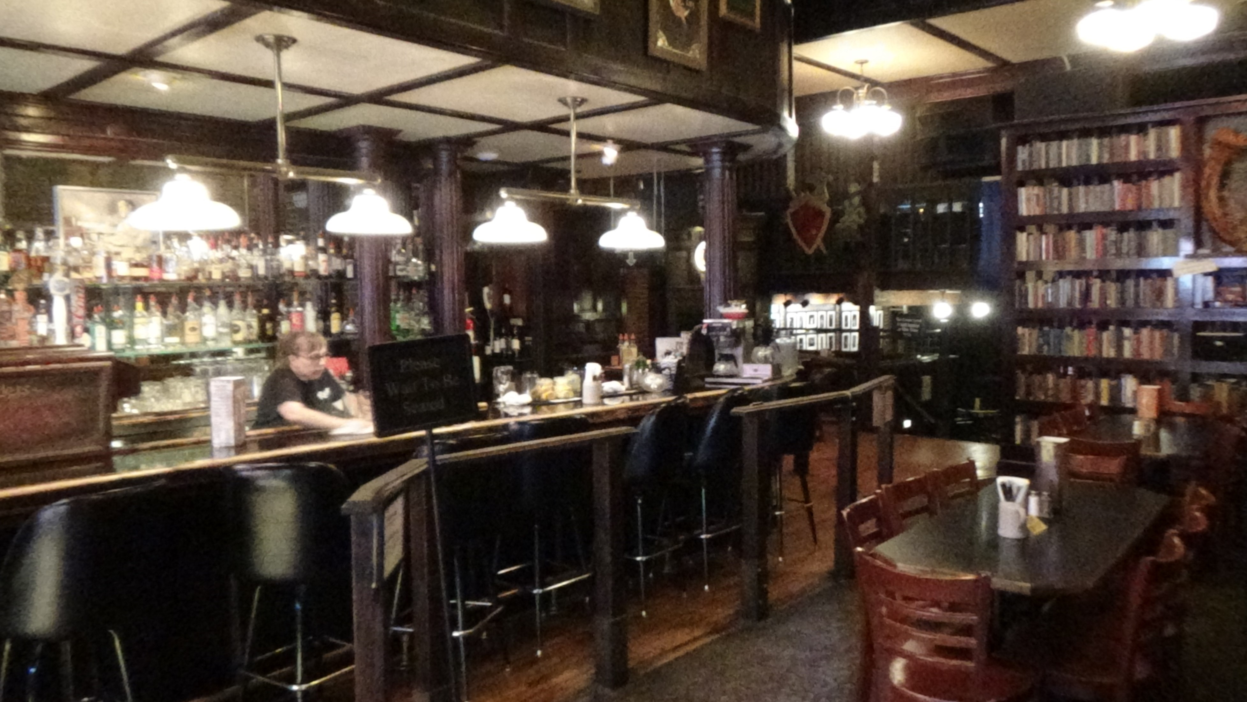
At the same old wooden bar I had a stout, and got the owner’s story of taking her kids to the Oregon Coast on vacation. The Sage and I drove down once on the way to San Francisco. I said I was glad to see the bar had survived the covid lockdowns. Linda, I think her name was, said the townspeople had been very supportive of the local establishments. They rotated from one bar one night to another the next, trying to give everyone enough business to keep going.
Though I wanted to linger on that stool for hours, maybe days, I made myself leave the bar and return to Spokane. The Palouse is a wonderful place, and I recommend the school to any student interested in what it offers. But I can’t imagine ever going back, unless Lovie follows in her mother’s sneakers by playing volleyball there.
But I’ll fly to see her.

AP (apnews.com) provides news and analysis content at the world, national, and statewide levels members can use as desired. The idea is that most news outlets can’t afford to send reporters to cover Congress or every sports game, so they pool their resources through AP.
https://www.historylink.org/File/11116
I never found an agent or publisher, probably my fault because I had moved on in life (I was at Mizzou by the time the proposal was done) and didn’t try hard enough. Within a few years the market was flooded with books on the topic.
Some college drama departments sponsor programs that present several shows in rotation with the same cast, that is, in “repertory.”
A theatre that can be configured in any way, a room painted black on every surface with move-able seating and a lighting grid covering the ceiling.

