Sat., July 22: Mike’s Jackson
The sign at the Flat Creek Inn has an interesting story, I learned the next morning while checking out. The columns supporting it were taken from the first bridge over the Snake River—in this region, I presume. I eschewed the free coffee or hot chocolate (“available any time” to hotel guests, a clerk told me) in the convenience store attached to the office. But I fed the Purple Sage breakfast at their pumps before retracing my drive out to Mike’s place.
He rents a room in an A-shaped two-bedroom cabin featuring beautiful orange-red hardwood walls and ceilings. The landlord is a woman friend who runs a theatre company in town, which of course means she has a day job, as a travel agent. Sadly, she was out of town, so I had to settle for briefly meeting her skittish cat. I had asked Mike if there was a laundry service in town, and looked online, and there wasn’t. So he suggested I use their washer while we went to breakfast, and then we could switch things to the dryer before doing our day. I threw on my best backwoods-bumpkin accent to complain I didn’t know how to run the washer, its controls being as complicated as “the Star-ship En-ter-prise.” After he walked me through the complications, I got the house tour.
It was full of smile-inducing, kitschy bric-a-brac and theatre stuff and cat toys. The cabinet knobs are individualized cutenesses, such as a smiling mustachioed man. An ancient red toaster oven graced the thick, wooden, finished counter. Up in his room, I teased Mike about no longer being a minimalist, as he confessed having developed obsessions with boots and backpacks while showing off his collections. Given how responsibly he has lived his life, I was pleased to see he felt comfortable enough to treat himself.
We turned north, going up the road I would have arrived on had it been open yesterday. Breakfast was at a local chain where I paid $17 for yogurt and granola and, I think, $6 for a small hot chocolate, while having a long chat with the cashier who drives back and forth to Florida each year. I was sorely hurt to meet someone who had driven farther than had I. Over our healthy breakfasts, Mike and I daydreamed about intimidating a guy that had been abusing his now-separated wife, a friend of Mike’s. I regret to say we resisted the temptation.
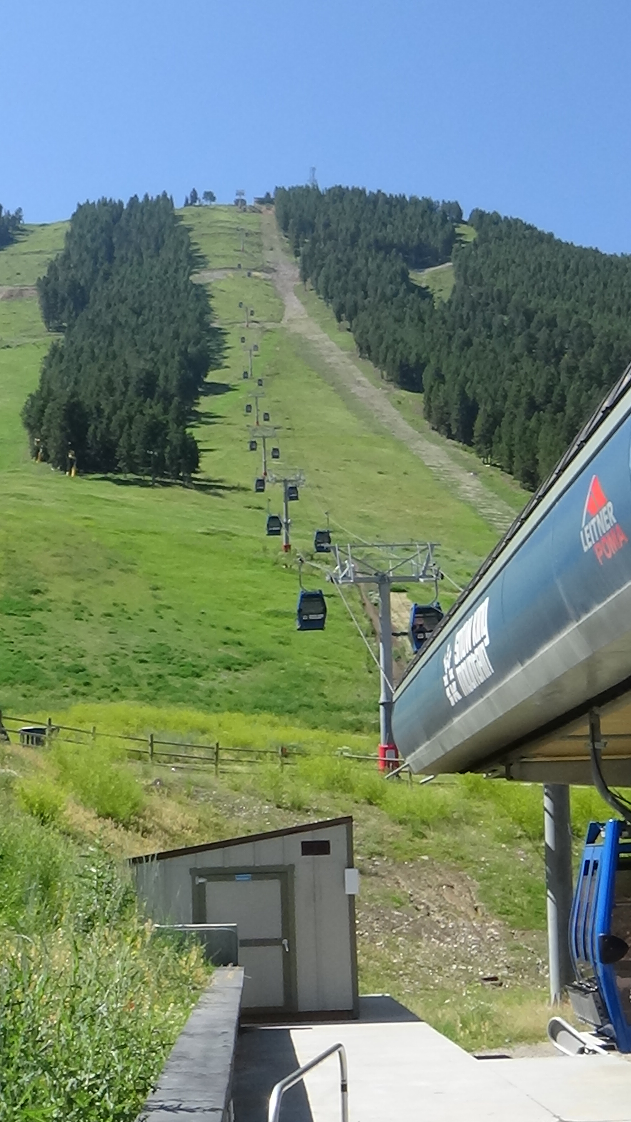
At dinner yesterday I’d told him, “I of course want to see the normal Jackson stuff, but I also want to see your Jackson.” When in the future he told me he had been to such-and-such place, be it a theatre or a grocery store, I wanted to be able to picture it in my mind. The Mike’s Jackson Tour began as we exited the commercial area the cafe was in by passing his roomie’s travel agency. After a stop to shift clothes to the dryer, he showed me the Transit Center where he caught the bus to work, a 10-minute walk. It has an attractive peak-roofed cabin for winter, with a porch for warmer months, and a set of bike lockers out front. He told me of a couple close encounters with moose on his walks, and with the far more dangerous bike riders who zip along the paved trail crossing the driveway-like road to his house. Winter walks were more of a challenge, obviously; he’d bought a pair of snowshoes after sinking to his knees on the way home one time.
Our plan was to start the day by hiking Snow King Mountain, which borders the south edge of the city, before the tourists got going. To be fully transparent, our plan was to hike down Snow King Mountain, after a gondola ride up. The town is at 6,200 feet, the top at 7,800. On arrival, though, we learned it would not open till 10. Easy enough, I said; we’ll do the drive on the day’s agenda first.
Back up 89 past the Flat Creek Inn we went, to Mike’s favorite overlook of the Grand Tetons. The sidewalk around the parking lot led past several history panels. He took us to one with a famous photo on it.
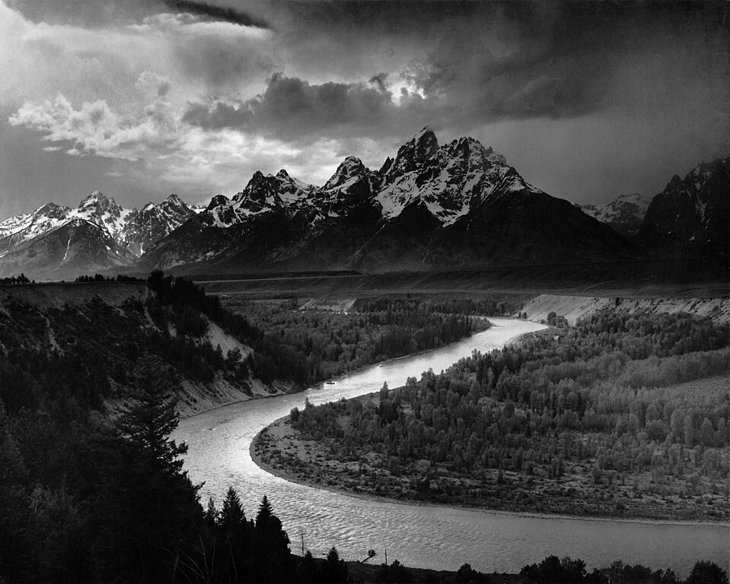
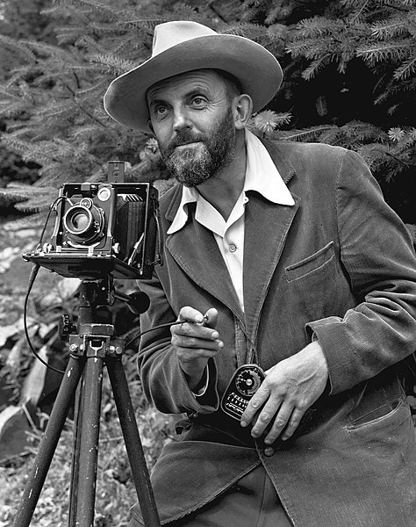
Ansel Adams was a talented pianist as a California kid in the early 1900s, but at 16 was given a camera that changed his life. He took a job as a custodian at Yosemite National Park in his 20s, where he began taking the landscape photographs for which he eventually became world famous. He published influential books on photography and on conservation, to which he devoted his later life. I’m willing to bet no matter your level of interest in photography, you’ve seen multiple Ansel Adams landscapes whether you knew it or not. One of the most famous was of the Tetons, taken from that exact spot. Like countless tourists before me, I took this re-creation, glancing down several times to check the framing:
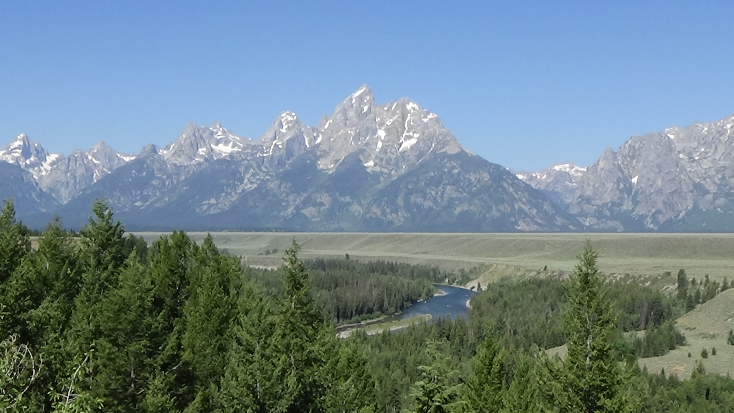
Yeah, his was better.
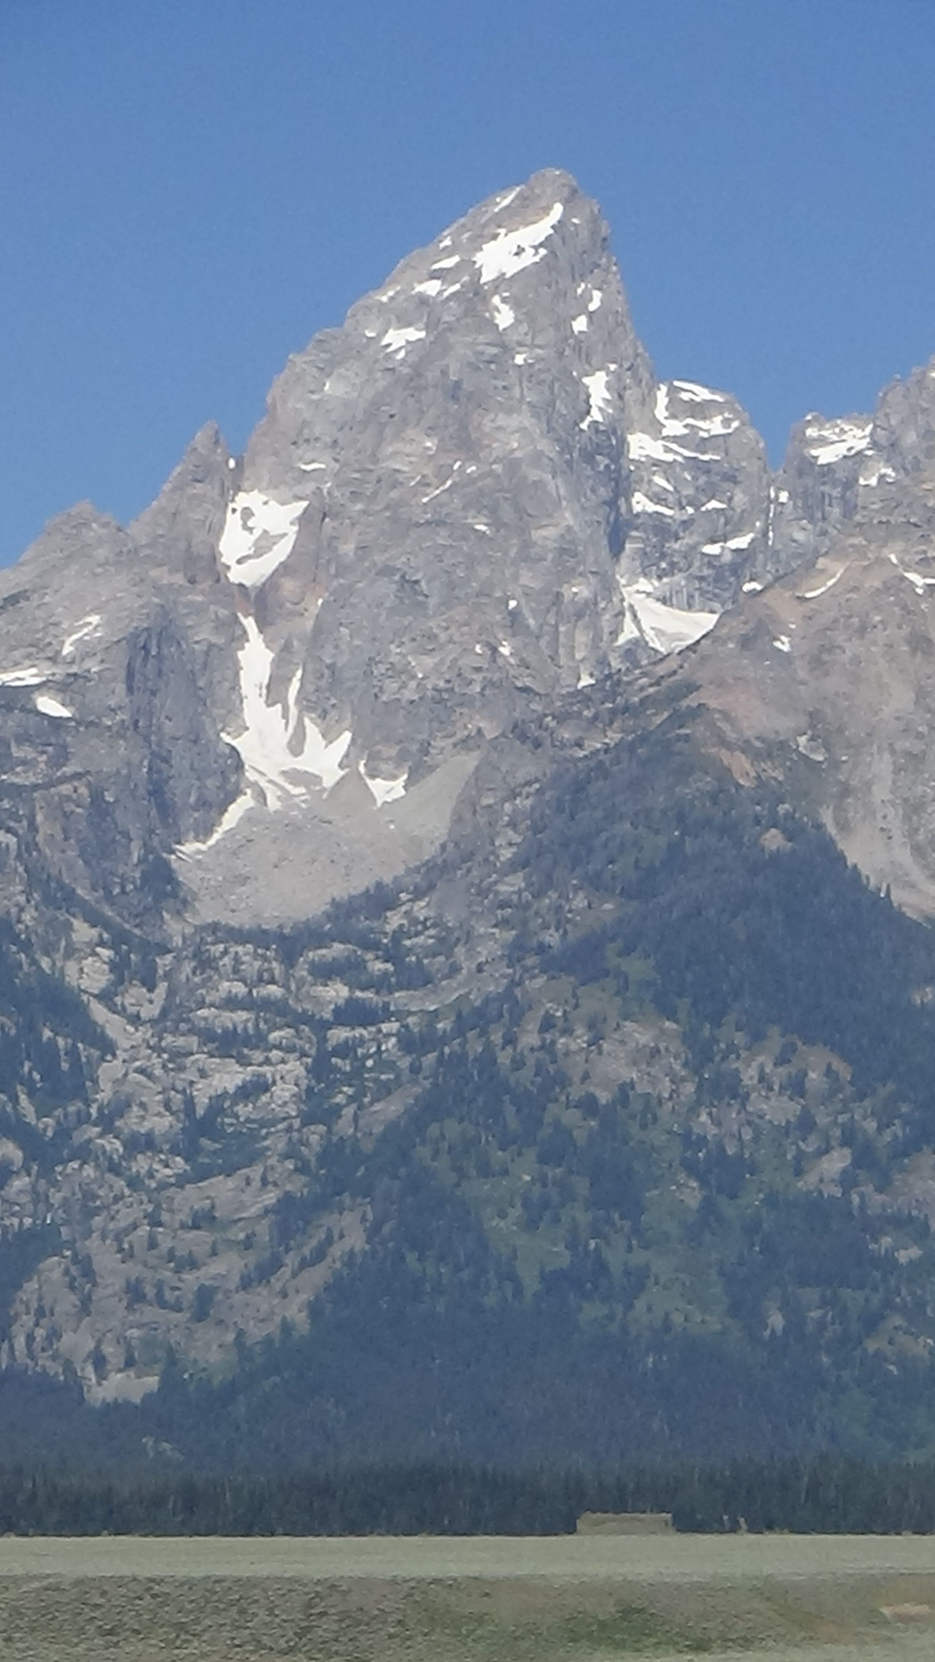
We backtracked to Mike’s second-favorite spot for viewing this extraordinary linear mountain range. The parking lot was already well inhabited by visitors. As we got out, I saw a woman in a sun dress with a serious look on her face, holding a tissue, walk past the car and into the scrub beyond the sidewalk. She didn’t seem scared or upset, so we went on to the viewpoint affording this glorious view of the peak called the Grand Teton. I turned back to check on her, and realized she was looking for someplace to pee, a difficult proposition in an area with no trees and few shrubs. Her only privacy was afforded by some disconnected rocks a couple feet high. I did the only thing I could for her, which was to turn around. I thought the Tetons were the most beautiful mountains I had seen, or could hope to see. Their reputation is well-earned. Yet I would be proven wrong this trip.
Back at Snow King, a line had formed before the small ticket booth across from the gondola. Mike had me shoot a QR code on a flier taped to the window, which brought up an online waiver form. This proved an irritation to someone involved in improving forms since they were typed in triplicate on typewriters. The form required me to fill it out as if I were a guardian with a kid, completing both a guardian section and user section, with some duplication of information. Done with that, though not with griping about it, I walked up multiple flights of stairs to gain the ski club building on a rise by the gondola. Happily for my bladder, it was open.
On returning, the ticket office was open. Check-ins of the people in front took forever, even though I had seen several fill out the waiver on their phones. When I got to the booth the explanation was clear, a college-age Russian girl by herself struggling with the system and the language. She asked several times how to spell my first name, such that I finally drew a “J” in the air. She apologized. I said, “Not at all—I’m impressed you speak two languages,” to which she smiled in appreciation. She was required to enter some of the same information I’d entered twice in the waiver yet again, but finally, I got my ticket. My name was spelled “Gim.”
To be clear, these problems were not her fault. Perhaps the most famous management guru of all time, W. Edwards Deming, said in business, regarding “most troubles and most opportunities for improvement… 94% belongs to the system, responsibility of management, and 6% special.” In this case, the system was bad, management provided inadequate training, and there should have been a native English speaker there to coach her.
Snow King formerly had chair lifts, Mike explained, which we both would have preferred, but now has four-person gondolas. Still, I enjoyed the ride and the increasing views. Up top, we noticed a zip line, and I told him about having one as a kid. In 1969 Santa Claus brought me via Sears a “Monorail,” as it was branded because of the one built for the 1964 World’s Fair in Seattle (still in use). It was—is, since I still have it—two in-line grooved wheels in a metal frame to which a small handle was hooked on either side of a central bolt. Somebody put the wire that came with it between two trees in the back yard, the higher end above a jungle gym I was given at 5. Standing on the gym, I would put the wheels on the top of the wire, hook on the handle, and sail away, slowing down enough to gently push off of the other tree. Such would never pass toy safety regulations these days, but it was the best toy of my childhood, and no one who rode was ever injured. Looking over its big brother on Snow King, Mike and I joked about knocking some paying customer out of the way and taking the plunge sans safety gear.
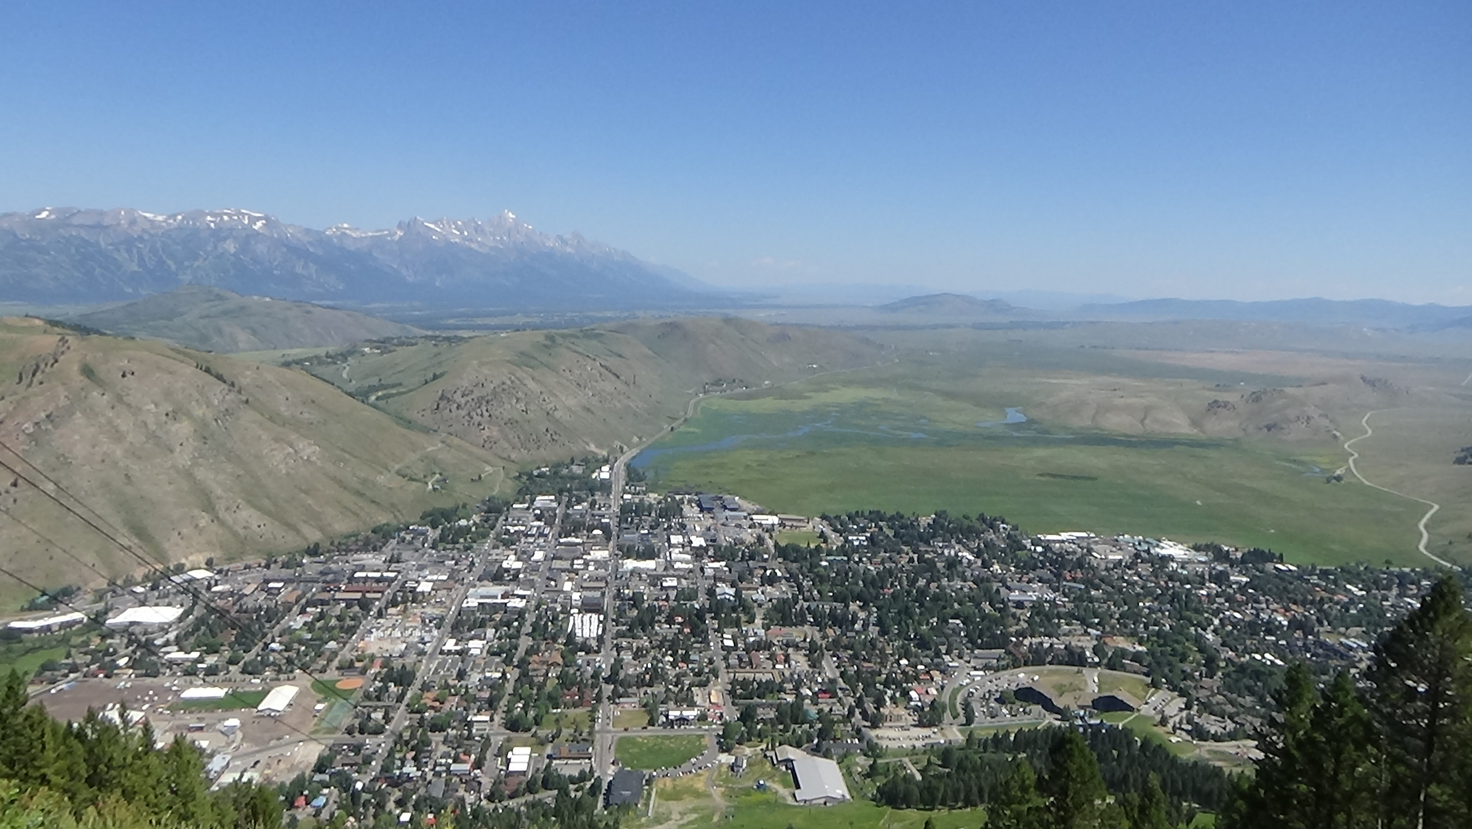
Instead we found a good viewpoint by walking along a construction trail. After snapping a phone pic of the two of us with Jackson Hole in the background, to make mutual friends jealous, I got the one below. (Out of respect for their privacy, I’m not sharing face shots of friends and family in this.) Mike confirmed something I had surmised by this point, that Jackson Hole is the entire valley, while the name of the town is just “Jackson.” News outlets seem to confuse the two regularly.
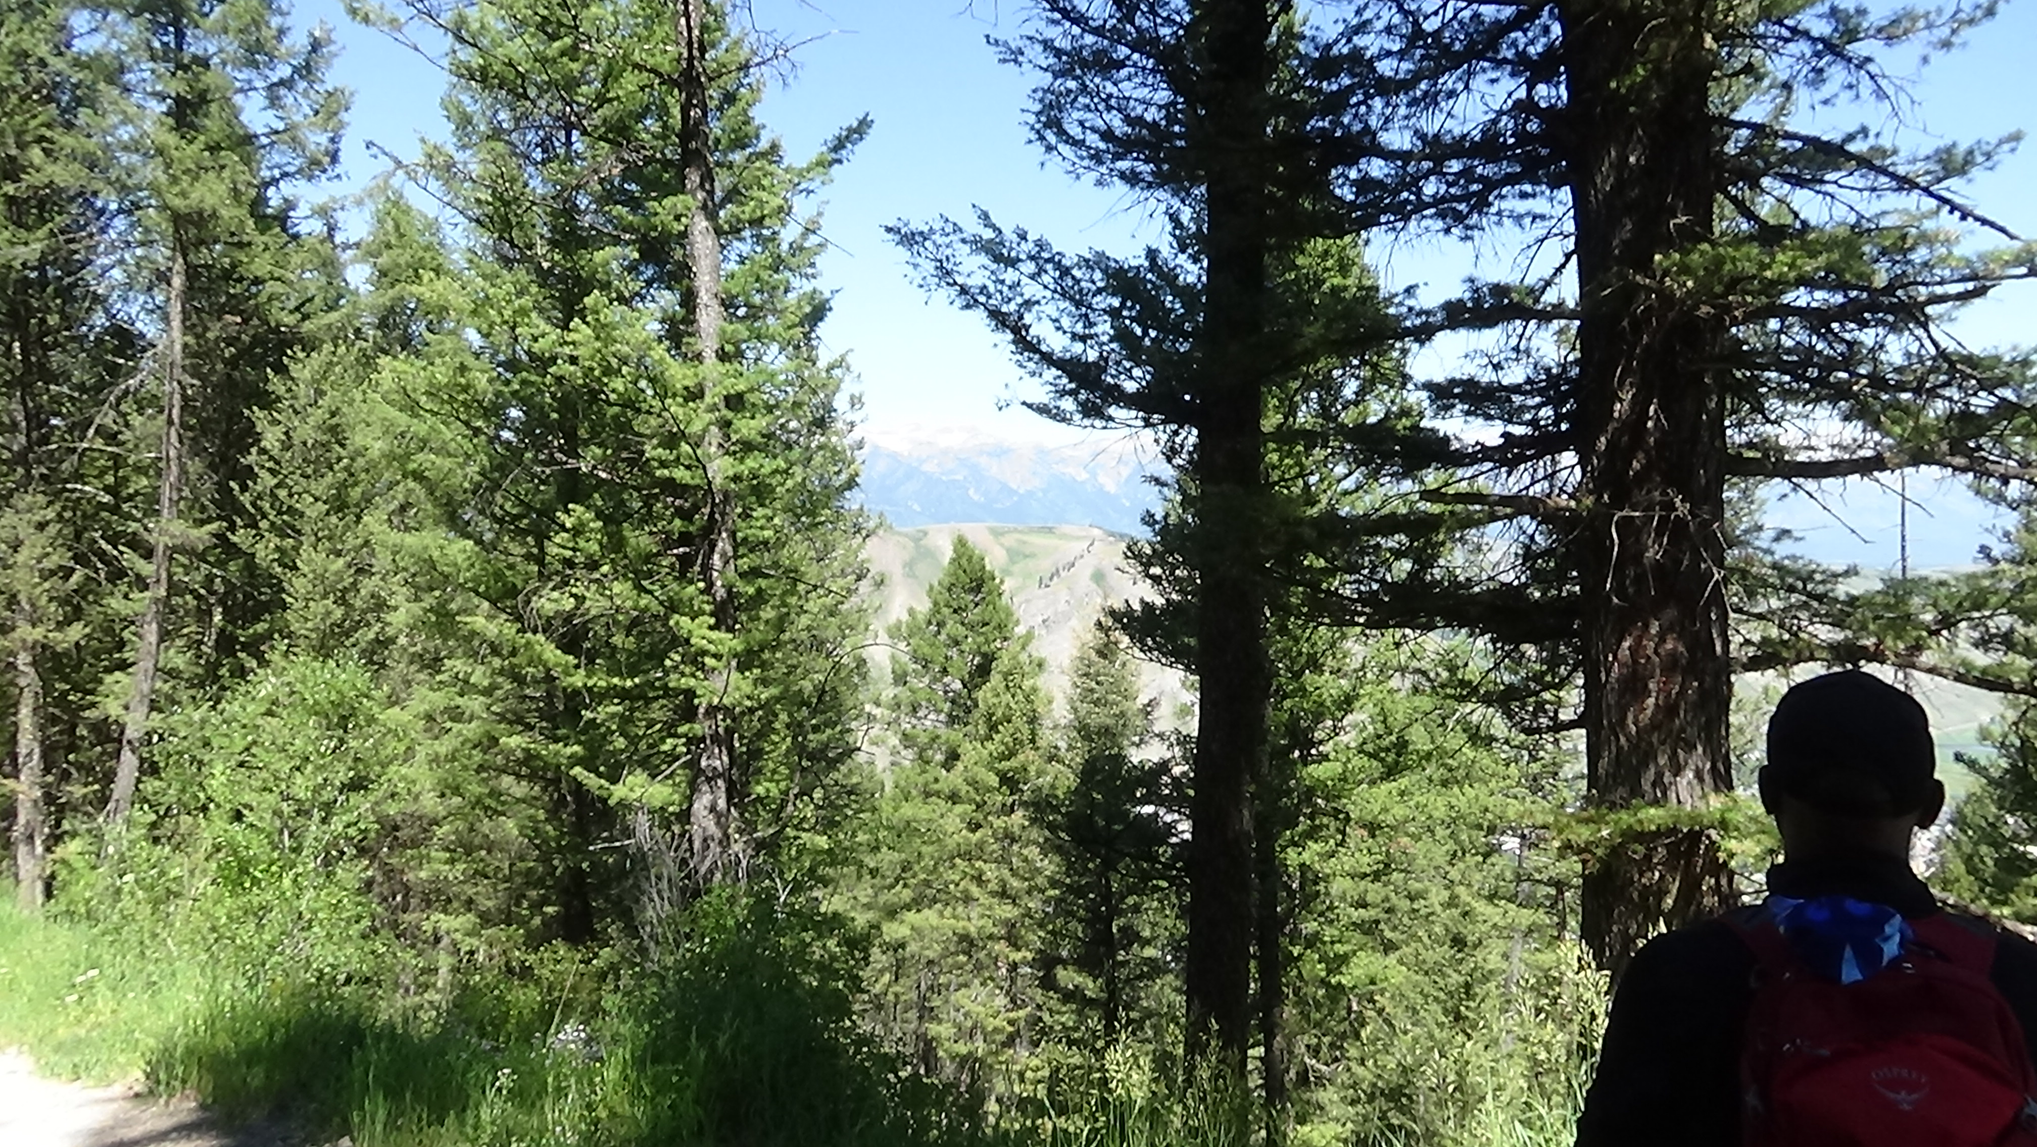
Because of the construction, the path downhill had changed since Mike was last there, but we finally found a route. Yet again there was no signage, and we soon realized this was not the trail criss-crossing under the gondolas that we wanted. Instead we were taken far to the west down a switch-backing gravel road. Later we did find a sign at a trail juncture, which made pretty clear we were on the right path: “Way Home.” At one point we paused for a water break, and I got a shot that isn’t great photography, but remains one of my sentimental favorites. This is Mike looking toward Gros Ventre Butte and his home hidden behind.
About halfw we passed a ropes course, which looked fun but is probably misused as an utterly fraudulent teambuilding activity. (There is zero evidence teambuilding exercises like that have any lasting effect on team performance.) Further down, thigh tops burning for both of us, we came across a gravity-powered roller coaster on which it seemed like people controlled their own cars with hand brakes, which seemed incredibly dangerous. We ended up walking cross-country for the final stretch, to arrive at what he recognized as Snow King Resort. We went through its grounds back to the car after a longer-than-expected walk, nonetheless fun because we were together.
Into town we went. He led me into the Center for the Arts a couple blocks south of the town square. A modern building with a variety of arts-related classes, we were there for two reasons. One is that Mike has acted here. While he took a bathroom break, I tried the theatre. Though it was locked, the lighting and sound booth was open, so of course I walked in. A guy in his 40s, I’m guessing, was at the light board, presumably the lighting designer for an upcoming show. “Sorry,” I said, “former techie just being curious.” No problem, he said. I added I was visiting one of their actors. He, hiding reasonably well his irritation at my interruption, asked whom. He didn’t recognize Mike’s name at first, which took me aback, until he asked about a particular play Mike was in. As it was clear I was bothering him, I omitted the series of techie questions I wanted to ask and left.
Our other reason for being at the Center was the two-story wall of windows on the south side affording a perfect view of Snow King Mountain. This, in turn, was part of why he usually starts his working day by grabbing a coffee at the adjacent shop and collecting himself while enjoying the view.
Mike is a member of SAG-AFTRA, the actor’s union, which was on strike at the time. He was wearing his union cap, prompting me to teasingly ask why he and Harrison Ford and Calista Flockhart—famous actors, married to each other, with a ranch in the area—weren’t out picketing. He noted there were no other union members in town. I joked he should go picket the local movie theatre by himself. In this town he was sure to get on local TV.
We walked a few blocks back to his store, J.D. High Country Outfitters. On the way we ran into one of his co-workers, which turned out to be one of three young men from Mississippi working there. Two had visited the area to go hunting and ended up staying. One whom I got a chance to speak with said he was looking at heading back South before winter.
Speaking as someone long involved in management training and coaching, I suspect their treatment by their managers was part of the reason they stayed. This family-owned operation is run right. For one thing, Mike was not looking for work, and had zero retail experience, when he was approached by one of the owners about taking the part-time gig. They recognized he had the character and personality that would make him excellent at it. They were right: While we were there, a co-worker asked for advice regarding binoculars on behalf of a customer. I was left on my own a bit while Mike made a sale on his day off!
Before that, he had toured me around the joint, packed with both stuff and people. While doing so, a random twenty-something asked whether a cap looked okay on him, his friends having given him a hard time. We agreed he looked fine, me preventing myself from adding, “It’s just a ball cap.” They may have been a little drunk.
Unfortunately, I couldn’t find anything to buy with his employee discount. I’m not very outdoorsy. Winter sports are too expensive for my taste, especially given that they would involve travel costs where I live. I love doing day hikes. But at the end of the day I want to settle into a bed, not a sleeping bag. And we vegetarians don’t tend to hunt. I could’ve used a hiking shirt, mine being a bit pilled-up from going off-trail a lot for the American Revolution work, but they didn’t have what I was looking for.
On the second-floor veranda, a consignment sale was going on. Mike had set up a hunting telescope the last time he worked, as a demo. He had me look through it at a couple spots he’d pointed out from the mountain. It was remarkably clear. Fort Kearny could’ve used one of those.
At my request, he showed me his favorite handgun ($2,600), too heavy for my skinny arms to aim easily, and favorite long-arm, a shotgun that was “only” $1,700. As with cars and designer clothes, I don’t understand why anyone would pay those prices when they could get something equally effective at least 25% cheaper slightly used.
He told two stories of retail hell. One involved a man who harassed him about wearing a mask during the covid days, and threatened to take his business to the next gun shop. Knowing the next one is a couple hours away, Mike invited him to do so. (And to my earlier point, his managers were fine with that.) The other was about a gun buyer who refused to understand why he could not take a gun home, which he’d paid for, because he had failed the federal background check. The issue was minor, the guy argued. As soon as you get that cleared up, you can have your gun, Mike answered.
We had lunch in town at an upscale cafe, where I picked up a copy of the free Jackson Hole Daily. The lead headline was, “Climber dies on Grand.” The second article was a cautionary tale for Jackson: “Tahoe tried to tackle tourism.”
I led him to the local history museum, which he was not aware of. I had noticed it on the first drive in. I teased him as we walked, “Aren’t you glad I know this town so well, that I can show you around?” Despite a poor layout, I was able to put together that the valley was too remote to attract the kinds of emigrants we’ve seen on the Trails. So the first homesteaders didn’t arrive until the mid-1880s. The soil could not support cash crops, and the standard homestead grants were not large enough for ranching. (The federal government gave away stolen Native American land in 160-acre plots.) Area homesteaders thus turned to “dude ranching,” meaning the town and surrounding area was built on tourism from its EA beginnings. A clubhouse and mercantile building were on the square by the 1920s, around the time the first celebrities showed up. The building still stands, and is still a retail space. Both it and the square were too human-filled for us to discuss shoving our way in, however.
Perhaps the biggest threat to Jackson was the richest man on the globe in the 1920s, John D. Rockefeller, exhibit panels taught us. He “earned” his money by being born to the founder of one of the first oil companies. In cahoots with a National Park Service official, Rockefeller set out quietly to buy up much of Jackson Hole using a front company. His first intention was to turn it into a national monument, created by presidential fiat under the Antiquities Act. When word got out, protests over the secrecy, and political fights, eventually brought a compromise. The land he’d already bought was added to Grand Teton Park, but further use of the Antiquities Act in Wyoming was blocked.
Per my earlier comments, I’m leaving out a lot of my visit with Mike. Suffice to say, it was huge to me not just to see him, but to get mental pictures of his life in this town whose problems seem far removed from many concerns of the day. For example, one problem is that most of the people who make the town tick cannot afford to live in it. As already pointed out, it is far from diverse, even by the standards of the highly white Pacific Northwest. The economy is entirely tourist based. Even he couldn’t pin down, when asked, why he felt comfortable here. For now he does, though, and I’m glad I got a chance to experience it.
That said, I complained then and will until one of us dies that he utterly failed to show me any wildlife. I heard stories from him of elk, bears, wolves, and moose, including one of a moose as close to his house as deer get to mine. But not one of these showed themselves, for which I entirely blame him.
As we returned to the car, he said before I could that we should get ice cream. We hit a place near his work. Of course I got huckleberry again, this one better than that at Devil’s Tower.
Back at the house, I put away my clothes, and we hugged our good-byes. This time, we already knew when we would hang out again, which may have been a first. We were close at NCSA, but he graduated a year before me as I was starting a long sink into a mental health crisis. Not having seen each other since, we re-met at an NCSA reunion in 2013. He was rotating among different towns for work, but based in Charlotte, N.C., allowing us to see each other sporadically either when he was passing through Durham or I made the occasional trip there. We never had any idea when our next visit would be. But in this case he had already planned a “Kith & Kin Tour” east, as I called them when I lived out West. His departure date was one of the constraints on my trip timing. Thus we knew the exact date he would overnight in Durham and could say, “See you in a month!”
I drove back to WY 22, and this time turned west for what became a beautiful drive over the lower Teton range, following Trail Creek over a gap with 10% grades into Idaho. A shift across the headwaters of the Teton River took me over another gap in the Big Hole Mountains. Then I caught back up to the Snake and rejoined US 26, which we’d last seen near Laramie.
Along the way, I spotted an adolescent moose in belly-high brush. This does not absolve Mike Johnson of his wildlife failure.
In Idaho Falls, I missed turns I didn’t think I could possibly miss, which took me through town instead of around. In at least one case, the lack of signage seemed purposeful, meant to send one through the commercial district. I finally winged a turn and got to Interstate 15. This took me the last 45 minutes back to Pocatello for the first time since Kerrie Rasmussen and I broke up in 1998.
We had met through the pre-World Wide Web version of online dating five years earlier. A service advertising in the local independent weekly provided a safer alternative to classified dating ads. You called a number and selected a voicemail box listed in the ad, a call for which you paid by the minute. After exchanging a few messages, we traded phone numbers, had some conversations, and finally tried a date in a restaurant she frequented. Within four months we were living together, and a year later we moved into my first house. I eventually asked her to marry me, which I should not have, because I already had some gnawing doubts. Eventually I had to break it off. Though working as a teacher by then, she couldn’t afford to move out, so we lived together in separate bedrooms for months until she could leave.
At the time I tried to come up with reasons, but I think it is simply a matter of having fallen out of love, much as I liked and respected her. Knowing what I know about myself now, I think I am too much of a misanthrope to see anyone daily and be that psychologically intimate. Of all my live-in girlfriends, roommates, and close friends, only one was sustainable at that level of contact. Had my best friend of three decades, Steve Charry from NCSA, been a girl, or had we been gay… But he apparently was the exception that proves the rule.
After taking a planned and purposeful break, Kerrie and I re-established contact and reached the ability to hang out on occasion. But I think my moving to Seattle in 2000 made things easier for both of us, and now she is one of my closest and most reliable friends. We have long calls, upwards of 90 minutes, every 2–3 weeks. But we hadn’t laid eyes on each other for 23 years.
By lovely coincidence, a Quality Inn meeting my criteria was just the other side of the interstate from the home Kerrie grew up in. A week before I arrived, she had moved back for a horrifying reason: Her energetic, witty, and irascible mother Sharon had been diagnosed with dementia. Unable to convince her to move to Albuquerque, Kerrie was making a hard and honorable sacrifice, giving up her life to care for a woman rapidly disappearing into mental oblivion. Her arrival date was the other constraint on my trip’s schedule.
Checking in was a slight adventure, because the harried solo clerk—a phrase that applied at most places I stayed, a sign of the ongoing labor shortage in this country—was trying to calm down a “Karen.” I refer to the slang for a privileged white woman who, in my interpretation, has few valid life concerns and thus makes mountains out of molehills. One of hers was racist in origin, regarding a Hispanic man I had passed sitting on grass by the ramp to the front door, having a beer and chatting in Spanish on the phone. I thought it unusual but didn’t think much else of him. In addition to her loud and repeated complaint about her key card not opening the room door, she went off about the “scary” man drinking a beer outside. She didn’t actually say “spic,” but the clerk and I heard the slur anyway. The clerk explained he was a worker who had been living at the motel for two months—which suggests he must be highly skilled for someone to pay for that—he had never caused any problems, and this was his way of winding down at the end of his workday. Karen said he scared her and the clerk should do something about it. I was about to jump in when she finally walked away, bitching, as the clerk said she would speak to him.
The clerk then apologized for the delay. I told her I once did what she did, and she had handled herself well. (In the mid-80s I worked at a Quality Inn we’ll visit in a few days.) As she appeared to be Hispanic herself, I found a way to express my disregard for Karen’s fear of the guy, saying he didn’t bother me. Yes, I know, I’m a guy, and a black belt, but objectively this guy wasn’t doing anything remotely threatening. Had it been a white guy in a suit doing the exact same thing except speaking English, Karen would’ve barely noticed him. The clerk rambled about her tough day for a moment, and I was happy to listen before she went off to help Karen with her door. When I ran into Karen later in the hall, she seemed a bit embarrassed, which I suppose is slightly to her credit.
Kerrie was a bit hangry when I texted at 6:30, but held her finger(s), and soon after picked me up out front. It says something about the nature of our relationship that she was totally nonchalant—a half wave to assure me it was her, as she was in a vehicle I’d never seen, and no big scene as I got in. Frankly, it was as if we’d hung out yesterday. I liked it.
She took me to a fav faux-Italian place I think we went to when dating. I ordered an inexplicably named Veggie Chick, an open-face veggie-and-cheese sandwich, and limp salad. I took home half, figuring correctly it could be the next day’s dinner.
On the way out, I noticed a sticker on Kerrie’s car saying something like, “The more time I spend with men, the more I like my cat.”
I deserved that.

From the “Star Trek” television show(s), movies, cartoons, action figures, model kits, Halloween costumes…
For years I’ve said it was my father, but as I write this I realize that can’t be true. Daddy was 10 months away from dying of leukemia and already spending most of his time in the hospital. It must have been one of my sister’s boyfriends.

