Tues., August 1 & Wed., August 2

Tuesday: Highlights Geological and Emotional
Ann Marie was leaving, too. Her mother had died a few months earlier, and her California sister needed to travel to the town where mom lived for executor reasons. Happy not to have those duties, Ann Marie had offered to fly down and cat-sit. I followed them to the ferry by way of their stop at a McDonald's that was not the fastest fast-food branch I’ve experienced. Not a fan, I backed into a parking space past which they would exit the drive-through. And waited. And got out to make sure he hadn’t juked me as a joke by backing up to a side exit... no, there’s the corner of the Jeep.
Moments later we were at the front of one of the holding lanes for the ferry. We shut down, got out, and chatted before boarding started. Once onboard we went up to the top deck and circled it the entire trip. Ann Marie said she did this every day when she was working at the grocery store across the Sound. However, wind drove us to cover above the stern, on the leeward side of the superstructure. The crossing was both relaxing and difficult, knowing I was leaving for the foreseeable future a guy with whom I have a type of connection like no other, and his wife who is one of the most caring and nurturing people I’ve ever met.
One other friend came out to say goodbye. Mt. Rainier hung off in the distance, too upset at my leaving to come get a hug.
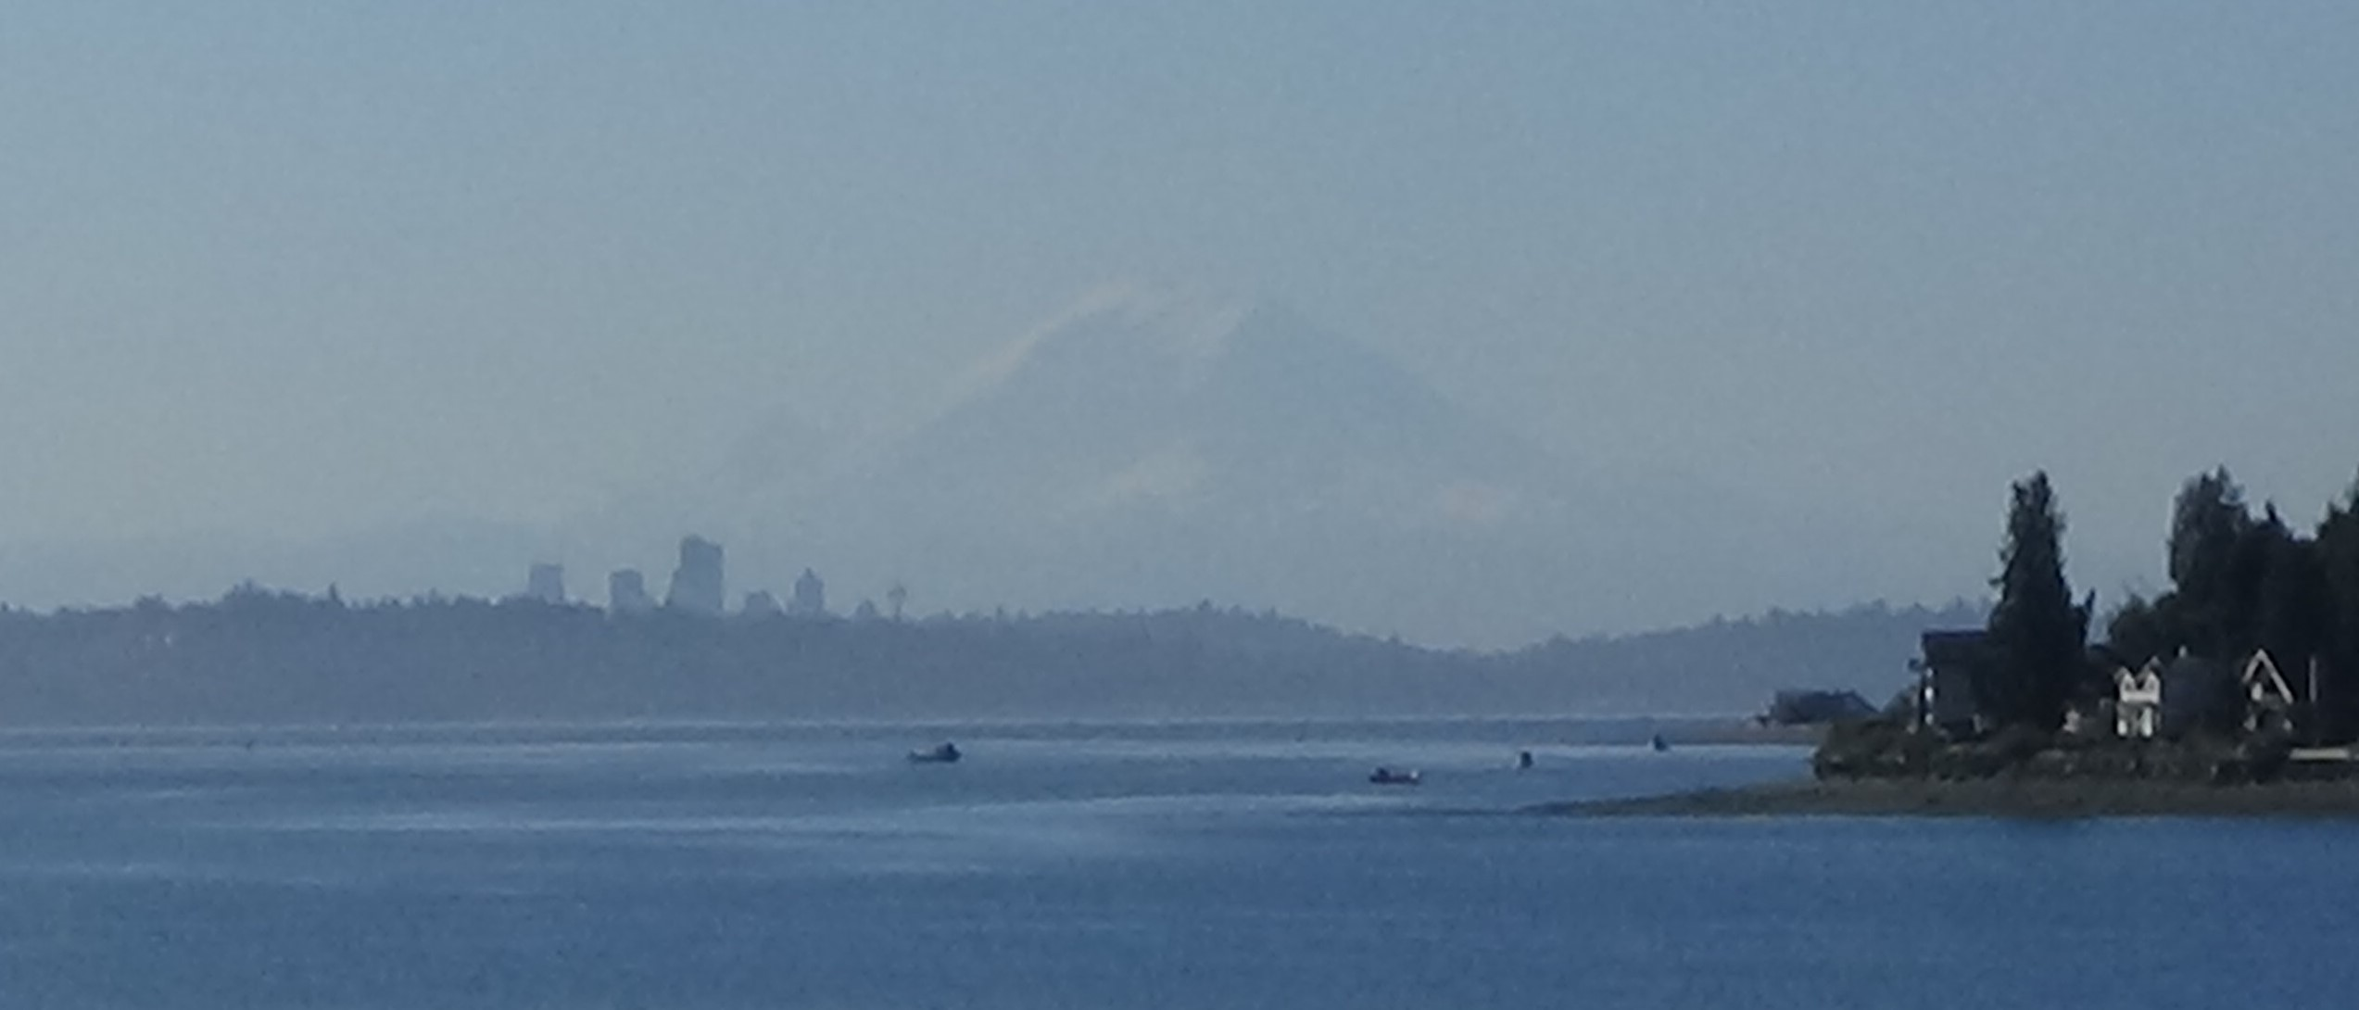
My return to N.C. began on a road I drove often in my Puget Sound years, around the top of Lake Washington. I was surprised to find many small businesses I recalled along the (relatively) low-rent commercial strips still there. The last time I was on that stretch, I was taking Minna to the vet from downtown. Now instead of turning south, as I did to get to my first two apartments in Kirkland, I stayed on WA 522 northwest. The Canadian wildfire smoke not having been too obtrusive as far north as Helena, I had determined to follow the advice of my new old friend in Oglala and take the northern route back as planned.
To that end, I picked up US 2 a few miles short of its western end. Roughly paralleling the Canadian border as few as 20 minutes away, until swerving down in Minnesota to get around Lake Superior, this would be my primary route east halfway across the country, to the tip of Michigan’s Upper Peninsula.
I had been on this part before, with my wife and stepson during my brief failure of a marriage, on a pleasant day trip. Both trips took me over 4,000-foot Stevens Pass in the Cascades, but this time I could stop to read some historical markers at a rest area nearby. The route the highway now follows took the usual development path of animal trail to Native American trail to road. The exact location of the trail is unknown, but artifacts found in the pass prove its NA heritage. The first road was built to take building supplies for a railroad around 1910. This was unpaved, though using “corduroy” in places—a line of logs running crosswise. Parts of the modern highway incorporate it.
A tragedy occurred here in the 1920s, when a train coming across became snowbound. A few people gave up on waiting for help and began making their way down. These were among the lucky few who thereby survived a massive avalanche that slammed into the train, its passengers sitting ducks. The pictures were terrifying, but I couldn’t get good shots for you. The railroad company then built more wooden snow sheds over the tracks, and finally drilled a tunnel. Based on my decades of experience in major corporations, I suspect some engineer(s) in that company warned upper managers they needed to build snow sheds, and the big shots ignored those warnings, killing 96 people.
Leavenworth, down-slope, is a rare and exemplary instance of innovative civic thinking remaking a small town for long-term success. Formerly hunting grounds for NAs, EAs arrived there for the usual Northwest reasons (gold and timber) and founded Icicle Flats in 1890. The town nearly died for a typical reason, too: a railroad headquarters moving away 30 years later. City leaders decided on a radical course in the 1960s, taking advantage of the surrounding alpine heights resembling those of Bavaria in Germany to create a faux-Bavarian town. Most of the area businesses pitched in to reconstruct the facades and décor along two streets, one renamed Edelweiss Weg (Way), and create German-themed restaurants and festivals. It worked. The primary web page I used for this write-up says the town of 2,500 attracts up to two million visitors a year, especially during the holidays. My brief little family especially enjoyed the Nutcracker Museum, with everything from old traditional European ones to Batman.
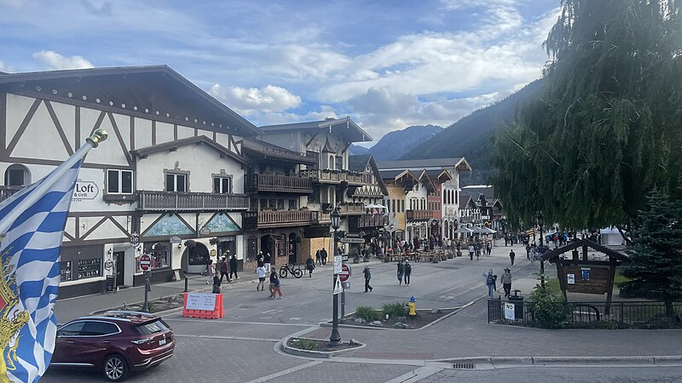(Public domain, Wikimedia Commons)
A short way down the road was Wenatchee, the town remade by the railroad hub moving there from Leavenworth. I’d been debating my route from there between two arcs, either staying on 2 up to Grand Coulee Dam, or taking WA 28 to visit a place I’d been curious about for 40 years. A digital signboard solved this conundrum by announcing the 2 arc was partially closed.
We wound through what I will graciously assume to be the visually unappealing part of Wenatchee. The Sage was desperate for a stop. Only one sketchy gas station presented itself that I could get to without causing a wreck. After crossing the Wenatchee River, on heading down its valley I finally found a Shell station at Rock Island. I did the usual prep of putting in my card and punching keys, and the pump operated normally right up to the point of squeezing the trigger. Nothing came out, and zeros hung stubbornly on the display. I noticed that a guy in a railroad service truck, there when I arrived, had pulled around to a different pump. A woman came over and said her pump wasn’t working, either. I took my first-ever $0 gas receipt and started peddling down the road along the river valley. The view was excellent for the price.
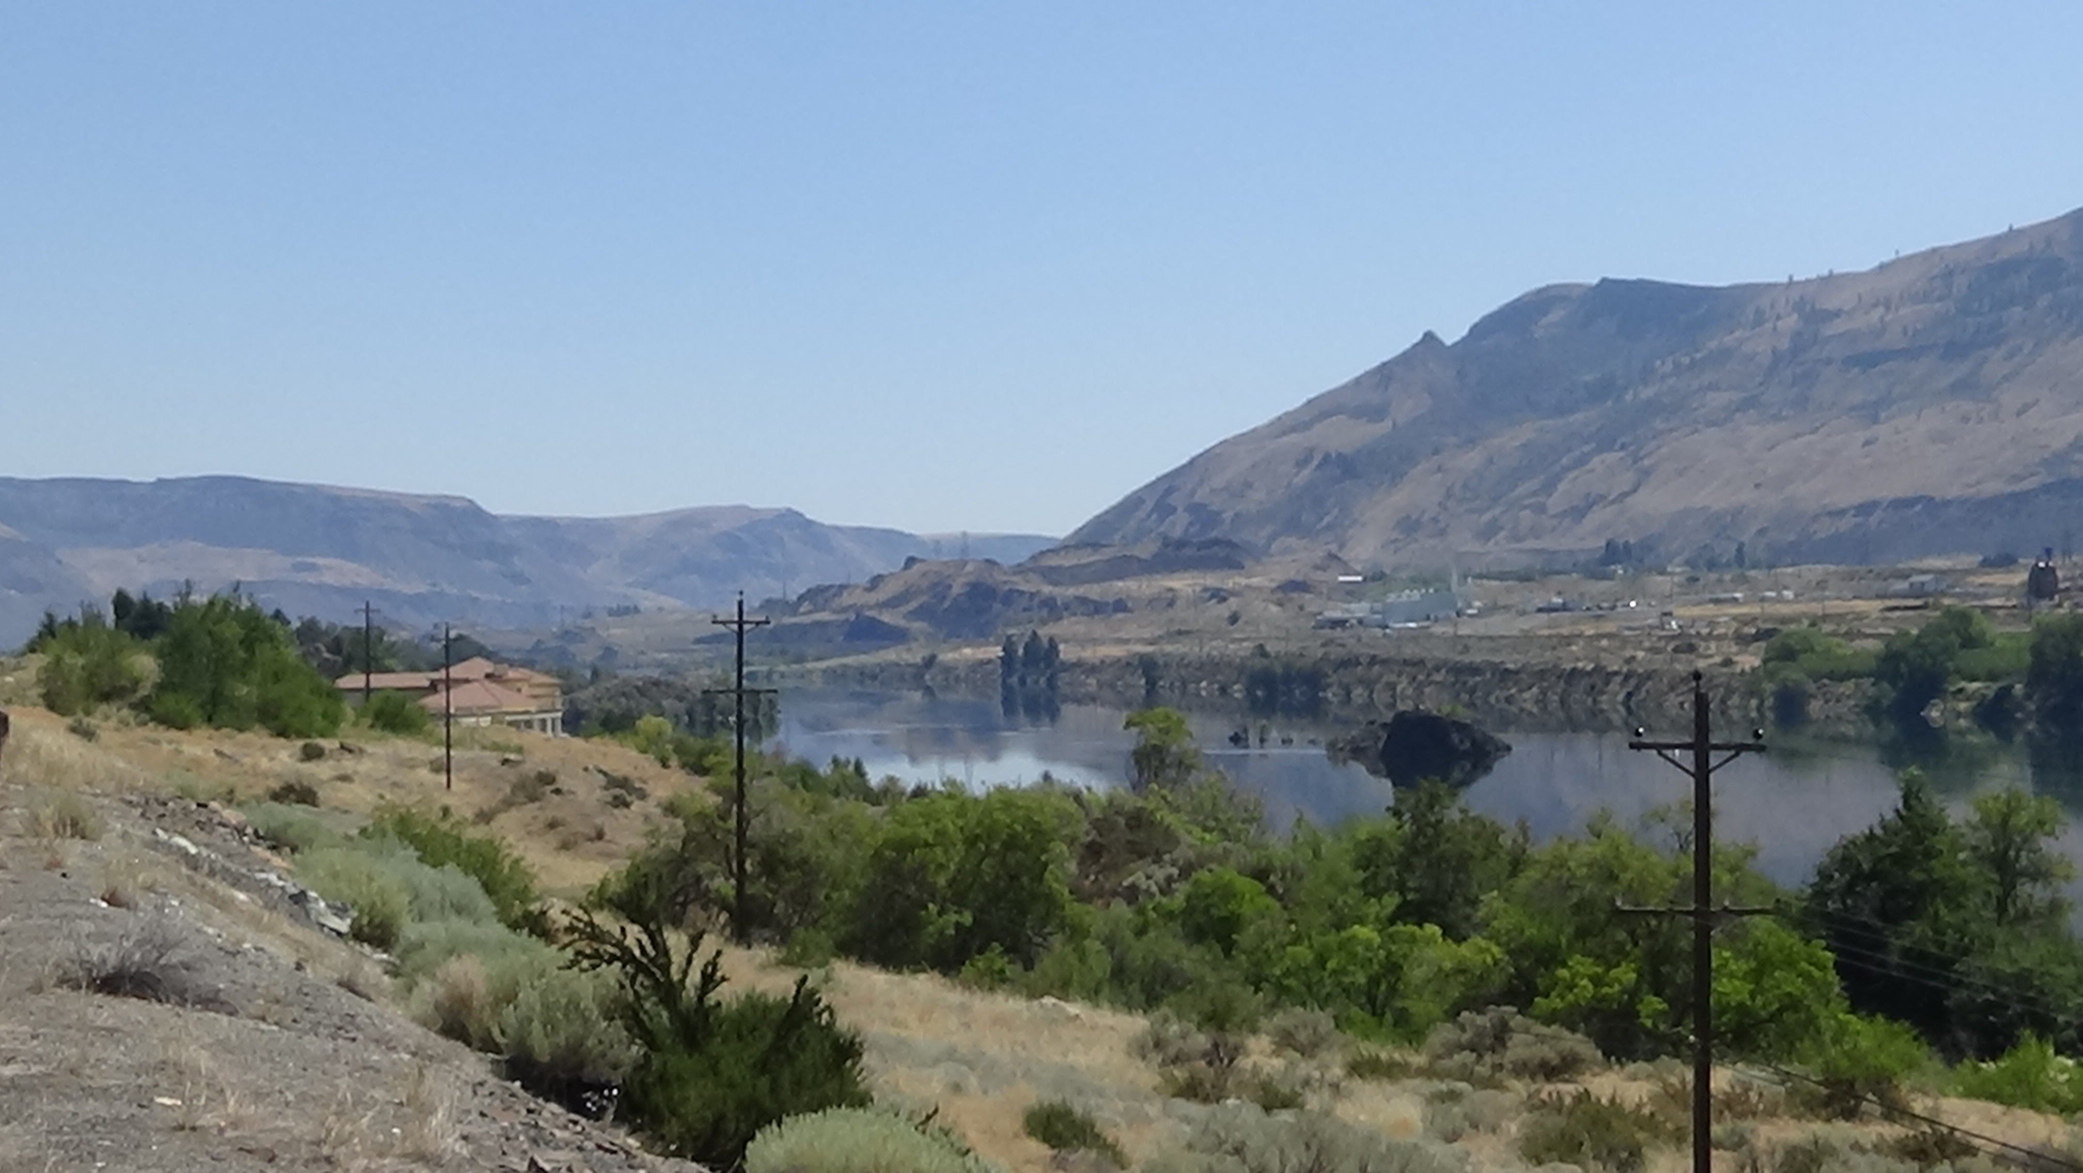
Approaching tiny Quincy, I found myself driving past an army of white metal warehouses, going on for half a mile. I muttered out loud, “What the hell are they?” Turns out to be a massive farm-product distribution center, possible several different companies, but Starr Ranch Growers was dominant. Their website says what started as an apple grower in 1934 was the first to export Washington apples, coming up with innovations for shipping its produce, even overseas. Now in its third generation of family ownership, it has 7,000 acres in various fruits. I’ve driven through plenty of farm country and written about agriculture, yet had never seen anything like the complex.
Finally I found a gas station to take care of the Sage, only to find the outdoor restroom was locked. I could hear noises inside, but after a five-minute wait, decided to hold on and move on.
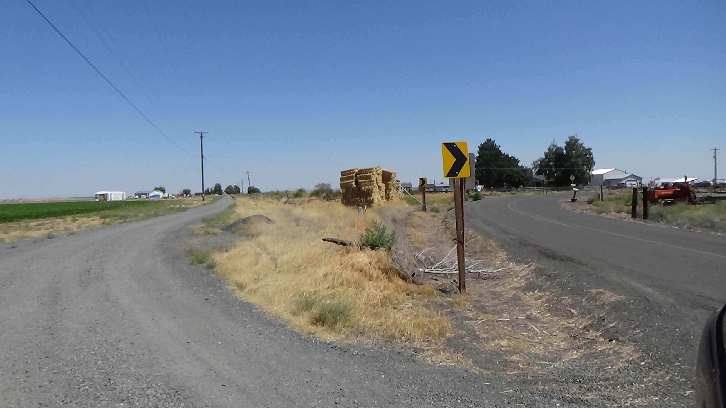
From Soap Lake I detoured south and then east, to arrive at the elbow bend in a back road where Jack told me he was raised, pointing it out on MapQuest the night before. The tales of his upbringing on a windswept farm in the Wenatchee River Valley had seemed surreal when compared to the artistic, urbane, spiritual-but-not-religious aesthete I knew. Jack had avoided the spot for years; I texted him a shot adding, “I cannot possibly connect the Jack Snowden I know to this.” He recalled having helped to build a corral in view.
Two routes from Soap Lake to where 28 rejoined 2 were exactly equidistant, but on spotting a bit of the Columbia River Gorge north of town my decision was made. This turned out to be fortuitous, for I would otherwise have missed one of the geological highlights of a trip filled with them.
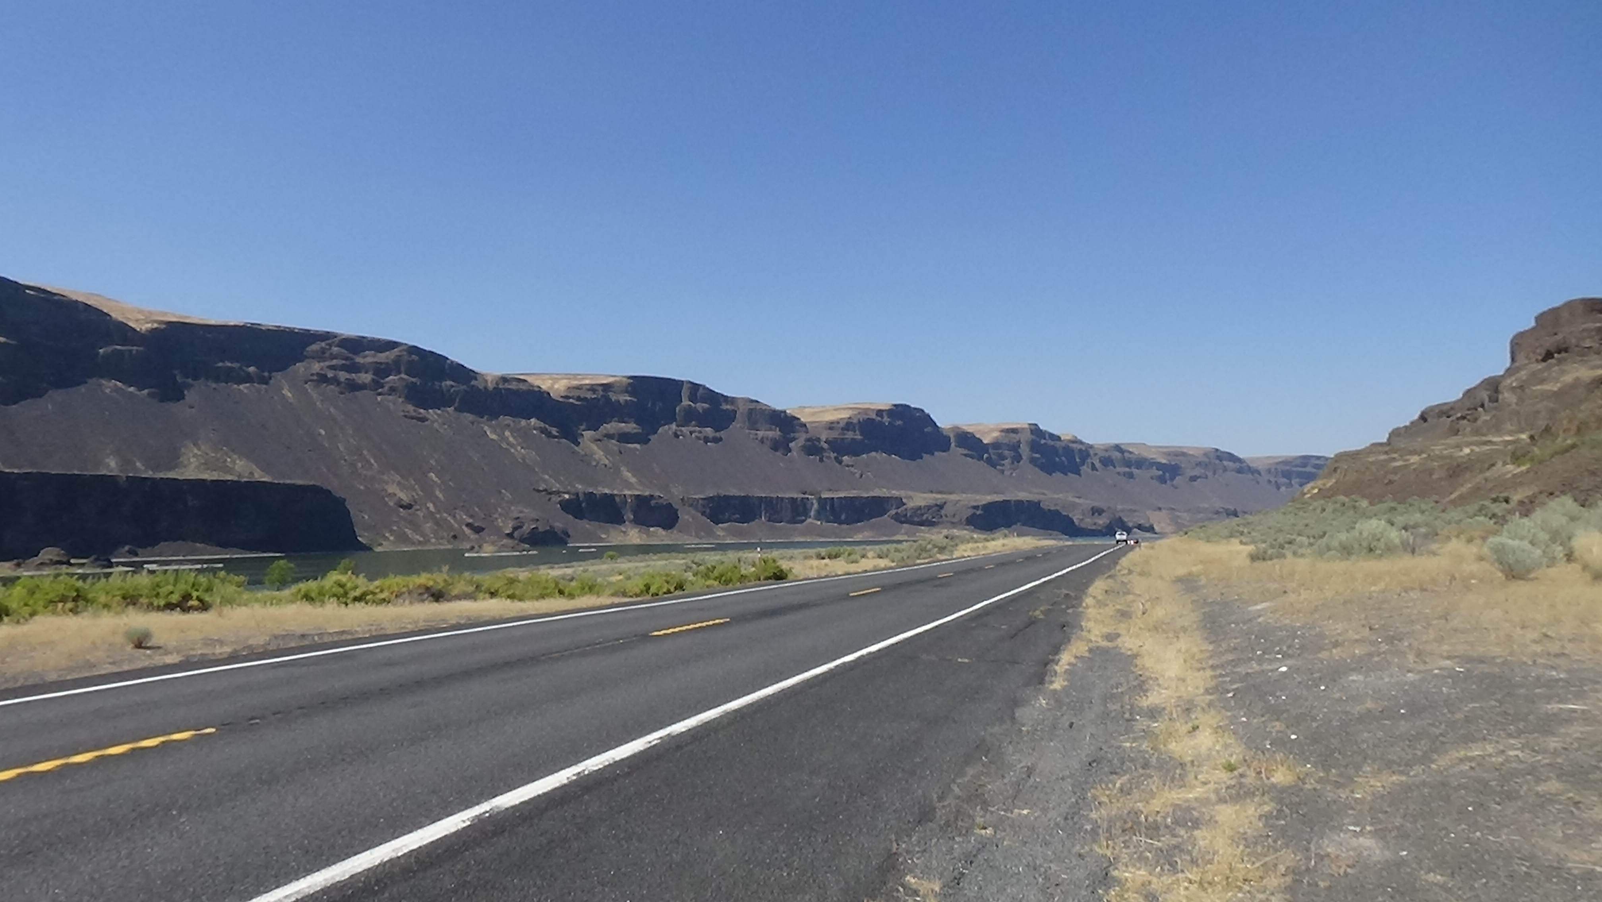
The last ice age on Earth—given climate change, I use the word “last” on purpose—ended around 10,000 BCE. Long before that, a glacier plugged up the Columbia River and made it shift direction. A river running through Idaho was stopped in its tracks by a similar obstacle, and kept backing up into a massive lake across Western Montana. Then the dam broke. All that water rushed west into the Columbia’s new course, forming what would become the largest waterfall anywhere on Earth, ever. What that left behind is 400 feet tall and 3.5 miles across. Niagara Falls and its Canadian twin, Horseshoe Falls, are a combined two-thirds of a mile wide, and less than half that height. They’ve moved about seven miles upstream over their long lifetimes; what now is called the Dry Falls State Park moved 20 in its.
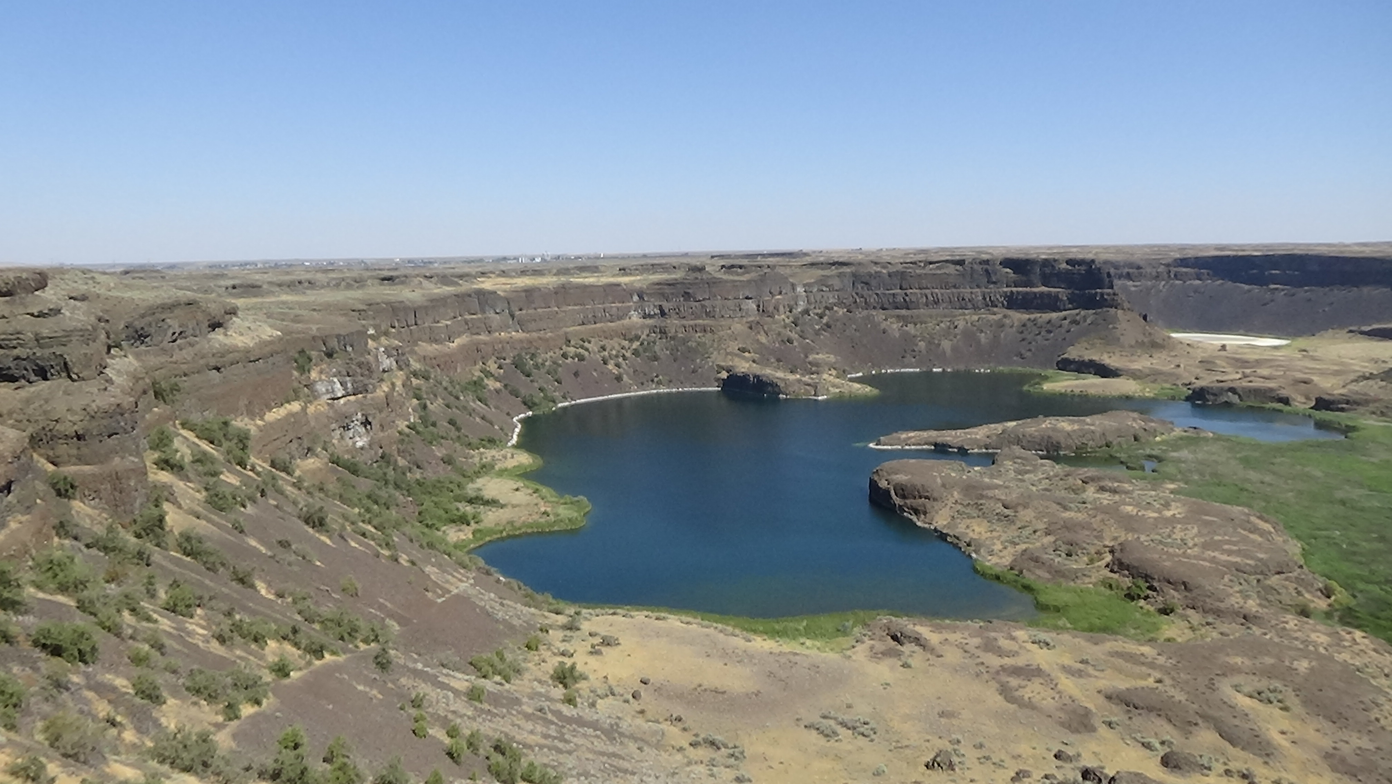
The northern slice shown above is a broad semicircle. The lake at the bottom was the drop pool of the falls. Sweeping south, as I did in another panorama vid, your jaw drops at the breadth:

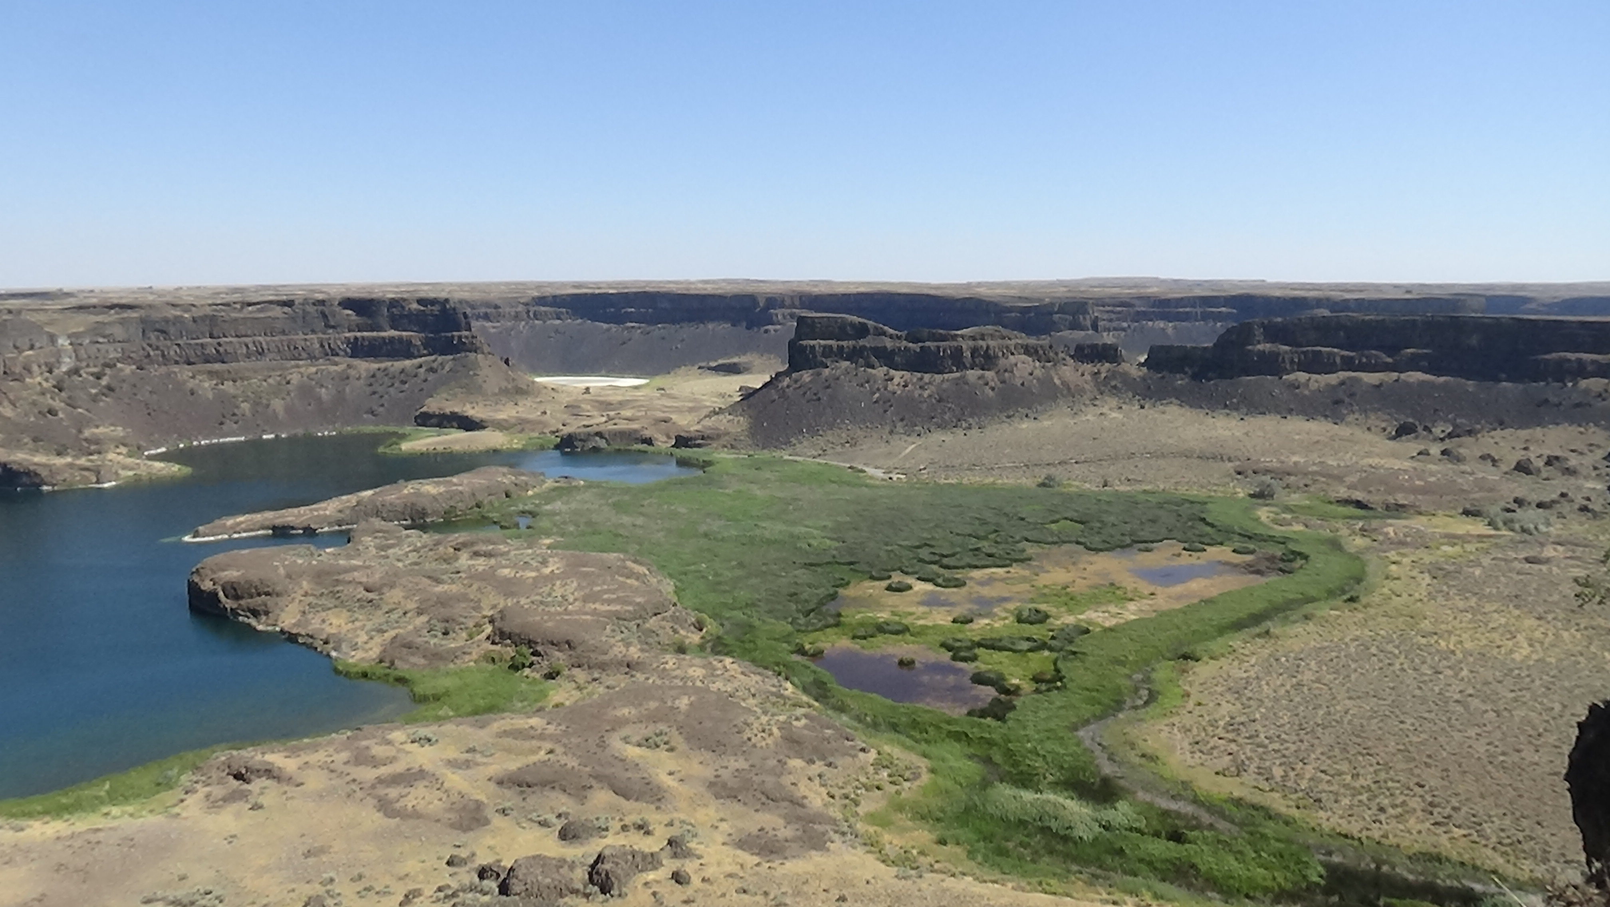
But wait, there’s more:
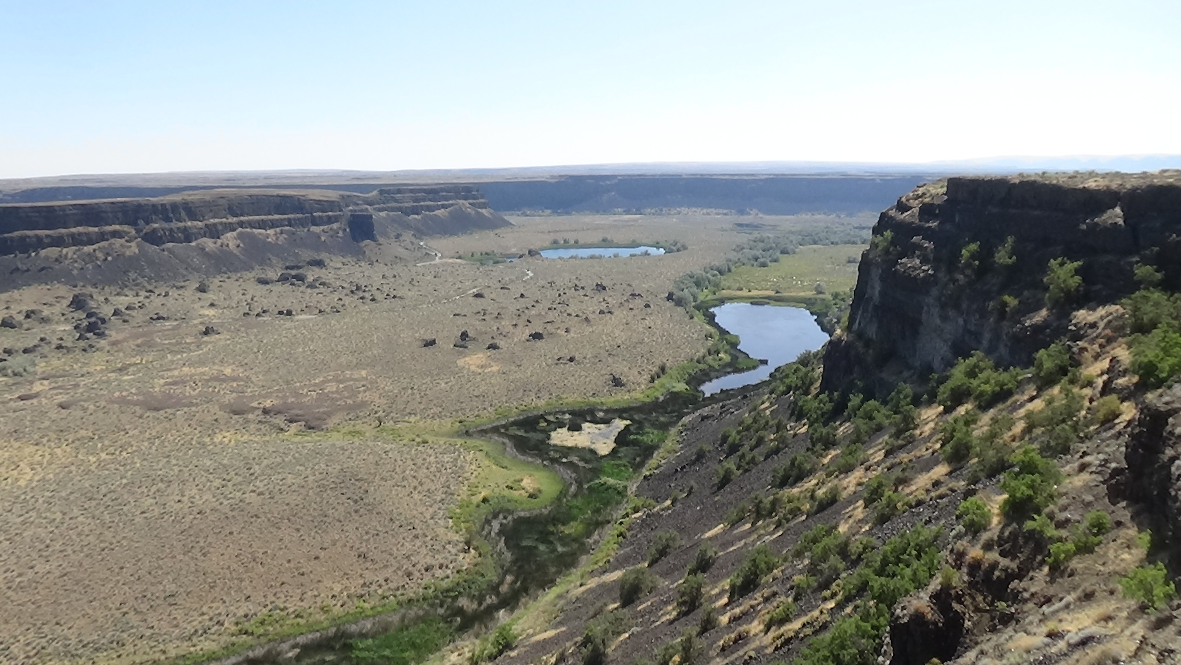
Words simply could not have done the job here.
Waiting for a narrow cantilevered overlook to clear, I heard an exchange between the two small family groups. One was Latino, the father announcing he was a pastor. The other identified themselves as Ukrainian, including a pretty young woman I would happily have married were there visa issues. The fathers bonded over their claims to “know Jesus.” I felt fortunate to slip around them without getting the same challenge. My Buddhist answer would not likely have gone down easy.
The last stretch of the drive, back on 2, was fairly mundane at first. Then it turned into the usual ugly retail strip found near every large military installation, in this case Fairchild Air Force Base. Fairchild is the home of massive bombers that stay in the air for long periods of time, refueling mid-air, while carrying thermonuclear bombs in case of the worst-case scenario for our species. I know because the owners of the Quality Inn in Pullman in my day, two brothers, piloted such.
Though delayed by rush hour, I finally made it to the Paces long enough to offload before meeting Lori and Lovie at the Mexican restaurant of the latter’s choice, Rancho Viejo. I was gratified by hugs from each, before we settled into a booth and ordered. I went for the veggie burrito, which was tasty if unoriginal, rinsed away with a Jarrisco Guava.
As I anticipated, Lori told me they wanted to hear the story of the Brazil trip. I gave Lovie a standard warning I’ve delivered to many kids over the years: “I think if a child is old enough to ask a question, they are old enough to get an answer. And I answer questions openly and honestly, so… don’t ask any questions you don’t really want the answer to!” She said she understood, and Lori double-checked with her. She confirmed she wanted to hear it all. Obviously I won’t be sharing this conversation with you, beyond what I’ve already told you. Suffice to say I reeled off the tale pretty much the way I do to anyone who wants the long version, minus a few gory details. Before I was done and all questions answered, there were tears all around. I teared up again as I told Lovie I wished I could have brought her dad back to her, because I knew what it was like to grow up without one.
At my request, Lovie then shared with me the difficulties of being an African-American athlete in a primarily white sport. She described micro-aggressions primarily, such as people inserting racial comments where race is irrelevant, often without realizing those are race-based or thinking they were being nice. Again I won’t disclose any more, especially given how grateful I am to her for sharing openly with me, an old-to-her white guy from the South. She is every bit as courageous as she is talented.
This one conversation justified every dime spent on the trip, the emotional highlight. I am so grateful they gave me the opportunity.

Wednesday: Side-Eye and a Slide
After an excellent breakfast of a veggie scramble and biscuit concocted by Guy, he and I ran some errands. At the grocery story, a shelf-stocker asked if I had found everything I needed. I asked about Clif bars, having finished off my last. She said, “I’m glad you asked,” which I thought was cute. She sent me in the right direction, and I stocked up. As we checked out, I noticed the quiet young woman was or had been a “cutter”: A cross-hatch of thin scars graced her forearm. I made no comment, but was impressed she was unselfconscious enough to expose them.
During my recent absence, the Paces upgraded to a self-propelled RV from a large trailer, which had become increasingly difficult for Connie to navigate. We went to the storage area owned by the neighborhood, near the end of their street, to clear out the old one. After off-loading at home, we tried to hit a flight museum in town, but it was closed “temporarily,” though their website tells me it still is three months later as I type this. Outside we could see a B-17, the smaller of the primary American bombers during World War II, and a 1950-ish Pan American Airlines plane with two propellers.
We went to Riverfront Park downtown, a location that has been drawing humans for thousands of years, because it centers on the site of a long set of falls in the Spokane River. Native Americans came here to catch salmon when those were swimming upstream—not only the local Spokanes, but other tribes who would join here to party. EAs eventually shoved them out of the way to build a sawmill and grain mill in the 1870s. A town grew around them, and the 1883 arrival of the railroad assured prosperity—for the EAs; the NAs, not so much. With the aid of an early power-generation station at the falls, Spokane had streetlights a few years later, before San Francisco did. Six years after that, Spokane had its own town-wiping fire.
The park formerly was the Spokane rail yard; the clock tower from the 1909 depot remains. But in 1974 the town managed to land the World Exposition, and the park was created for the Expo. We just wandered, stopping in for a moment to watch kids on the carousel. One gave me the side-eye. I fear she has been so fear-indoctrinated by her parents that seeing a couple of older guys innocently watching kids enjoy themselves took her brain to a dark place. I made a point to avoid another glance of her, but was not going to give up taking in this bit of Americana a while longer because of parental paranoia.
The former skating rink, Guy told me as we walked passed, had been turned into a “skating ribbon,” a curving track open for roller skating, and utterly deserted at the time.
I wanted to revisit the bridge used in a groundbreaking Native American movie from 1998, “Smoke Signals,” but it was closed for repairs. So I settled for what I think is a former railroad bridge, now pedestrian-only, for my view of what is left of Spokane Falls, tamed by upstream dams and that of the power station.
The centerpiece of Expo ‘74 and symbol for Spokane is an amphitheater with wire netting spreading over the terraces. Stairs and ramps lead up to the halfway point of the central pole. Guy patiently awaited me as I climbed to the high point, where I wished I had not taken the day off from the camera, so I could have captured the shadow pattern from the netting. A woman was standing at the side of the ramp. I couldn’t tell if she was on the phone or just in reverie. Either way, she did not acknowledge my existence, so I left her to hers. A third individual made his or her way down the terrace on the far side as I returned to Guy: A beaver had been busy in the bushes bordering the seating area.
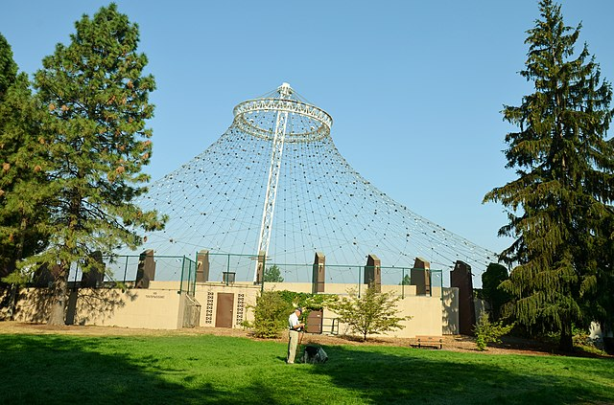(Credit: Roman Eugeniusz, Creative Commons Attribution-Share Alike 3.0 license, via Wikimedia Commons)
Guy led me uphill to a surprisingly effective Vietnam Veterans’ Memorial, a realistic soldier statue in a quiet spot overlooking an artificial channel of the river that reflected the convention center beyond it. He is a vet himself, part of the saddest coincidence on my life list. During a training exercise in 1989, the World War II battleship U.S.S. Iowa, still on active duty, had a disastrous explosion in one of the gun turrets. I was in Pullman. Knowing one of my closest friends, Allen Everhart, was onboard and assigned to a turret, I went to see Guy for solace. The last time a gun turret had exploded on an American warship was during the Vietnam War in 1972, on the U.S.S Newport News. Guy Pace was onboard. He had passed that turret a few moments before, and rushed back to help. Several of his friends were lost.
The next morning at 4 a.m., I learned Allen was gone.
Guy was upset that the city council was considering moving the memorial, which I well understood. The shaded, elevated spot seemed perfect.
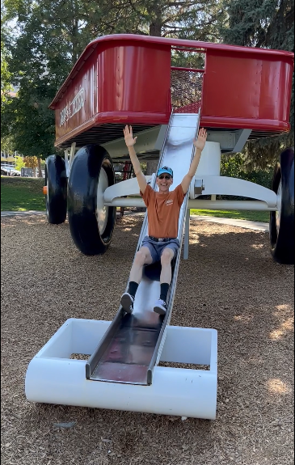
Walking back to the car, we passed what I presume is the world’s largest Radio Flyer—the quintessential little red wagon every kid wanted in the early part of the 20th Century. I had one, too. This one rises well above my six-foot height, with stairs up and a slide down. I assume it dates to the Expo, but it was certainly there by the 1980s when I last visited.
We went up to investigate how it was put together, and Guy joked that if I went down the slide, he would take a video. He should have known better. I promptly climbed the stairs despite the 30-ish couple already standing near the end of the slide. When I got to the top, the woman called out, “Now, you have to throw up your hands and go, “Wheeeee!” So I did, as she with her tablet and Guy with his phone filmed me. This is by far the favorite video of the trip according to all viewers of my slideshow. For all I know, the lady posted it, and I’m an Internet meme.
During our errands, after a stop at Target, Guy had walked us over to check out a new Indian restaurant in a space he said had gone through several iterations. I spoke briefly with the manager, who was Indian, and suspected it was pretty genuine. After we got home and told Connie about it, she suggested we give it a try. I ordered my test dish of any Indian restaurant’s quality, the saag paneer. This is a creamed spinach with cubes of fried cheese. Connie was not feeling adventurous, and went for a what in effect was a personal pizza they had wisely added to the menu for people like her. The manager, still there, came over several times, and he and I talked about my visits to India. “I’m going to shock you by eating with my hands,” I warned him. That’s what that flat bread that comes with your Indian meals, usually naan in this country, is for. I tore off a piece, grabbed some rice, grabbed some saag, and stuffed my face. Other than being less spicy than I got in the home country, it was excellent.
I couldn’t resist getting the manager’s life story when he came around again. He was from New Delhi, he said, to which I responded, “You must like the air here.” He smiled; Delhi is notorious for its pollution. He had first lived in Miami when he came to the U.S., but moved to Spokane due to friends, and liked it more. He said Spokane was more peaceful, quieter, and the people were nicer. Having been to three big Indian cities, including Delhi briefly, I entirely understand why “peaceful” and “quieter” would be appealing to him.
Another question I asked may seem invasive to you, but I had been on the receiving end so often in India, I knew it was not considered such there. I inquired after his marital status. He was single, and no, his parents were not arranging a marriage for him, still the predominate source of Indian marriages. “He wants a ‘love match,’” I teased, for which he offered a fist bump.
Back home there came an uncomfortable moment. I had predicted to N.C. friend Ben Covington that Connie would try to give me the money she would have spent on my plane ticket. “I hope you take the money,” he advised, knowing I would be averse. On the drive out I had talked myself into compromising by trying to talk her out of it, but if she insisted, accepting an amount significantly less than the ticket would have been. Sure enough, this had come to pass on my westward stint.
Tonight she came to me with more. I was stunned, trying not to be angry that she did not know me better, recognizing her good intentions and a bit of guilt I think she carries about her unearned financial comfort. The amount would probably bring the total up to full ticket price. Mashing competing values in my head, ego vs. Buddhist compassion, I said, “I’m starting to feel like a prostitute.” As she started to object, a pained look on her face, I heard Ben’s words in my head again and added, “I think I like it.”

https://www.historylink.org/File/9475
https://starranch.com/about/
Lori is white, so obviously Lovie’s at least as white as she is black. Lori has pointed out the same is true of Barack Obama, yet he is considered America’s first black president. This makes me think of the absurd laws in the South like the one that declared people 7/8 white to be black for the purpose of segregation.
Possibly meaning, “Children of the Sun”
Primarily drawn from: https://historylink.org/File/7462.

